Jessica Johannesen
ED 537C
Lesson plan

Title: Flash Debate Opinion Writing Lesson
Grade Levels: Upper Elementary/Middle School
Objective: Students will create an opinion writing piece through a cooperative learning flash-debate process.
Materials: Graphic organizer, sentence frames, pencils, red and white tiles to determine partners

English Language Proficiency Standards:

ELP Standard #2 participate in grade appropriate oral & written exchanges of information, ideas, & analyses, responding to peer, audience, or reader comments & questions.

ELP Standard #4 construct grade appropriate oral & written claims & support them with reasoning & evidence.

Vocabulary:
Claim: The main point the writer argues.
Counter claim: Opposing Viewpoint; disagrees with the claim. (This is not the focus of the argument, but it should be mentioned. )

Tip:
This lesson should be taught after the teacher has shared some examples of opinion writing. Before the lesson begins, review vocabulary for opinion writing, including claim and counter claim. Also display and read over the graphic organizer and state that each column will have 1 -2 sentences. This activity gets students talking before they have to write a paragraph. Often times, students feel nervous about writing and have a difficult time getting their words out on paper.

Graphic Organizer:
For this strategy, provide students with a graphic organizer with 4 columns that breaks down the structure of the paragraph or essay and sentence starters that work as a scaffold for each sentence. (Column 1: Stating a claim and giving a cause or reason for it. Column 2: Providing examples to support reasons. Column 3: Adding additional reason or examples. Column 4: Acknowledging a counter claim and disputing it.)

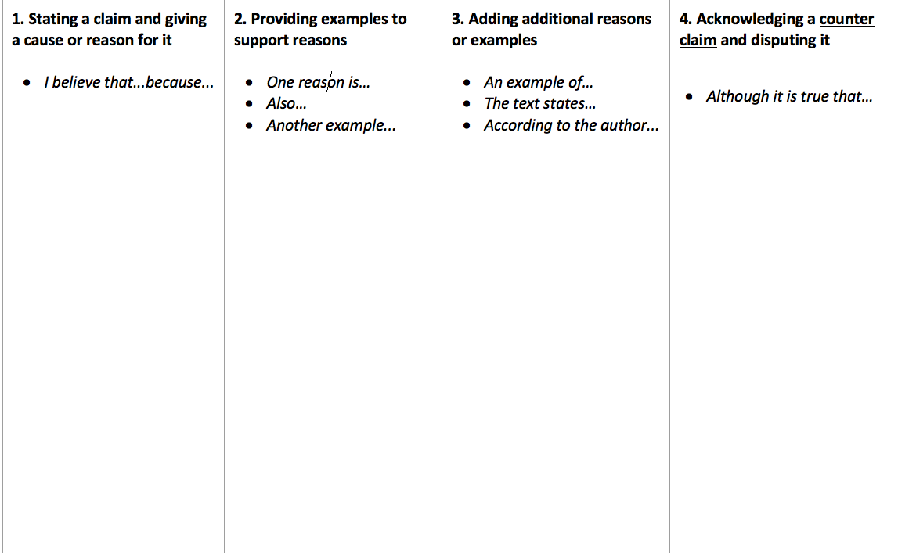

Modeling: The teacher will model the entire process and the students will help brainstorm ideas for the counter claim. Example 1: “School uniforms would be wonderful” and the counterclaim, “School uniforms would be terrible.” The teacher will show how to use the sentence frames and will use “think alouds” as she/he writes on the graphic organizer. Use two graphic organizers, one for the claim and one for the counter claim. Do this process fairly quickly, only spending a few minutes on each column.
- Write your first sentence using the sentence frames. “I believe school uniforms would be a wonderful idea.”
- Elicit ideas for the class for the counter claim first sentence and write it for students.
- Next, have a student do the verbal part with you or have the class choral read counter claim column 1. Teacher reads aloud column 1 for the claim and the student(s) read(s) aloud column 1 counter claim.
- Continue the process with all the columns.
- Lastly, Have both sides read aloud the entire paragraph. Model how to edit ideas as you do the process.

Activity:
Partner up students with Low/middle and Middle/high writing abilities. The teacher either assigns a side using the colored tiles (White-Claim/Red-Counterclaim) or the students can pick a side. Students will start by stating a claim and giving a cause or reason for it. (*See slides on the following page for topic ideas). Students should focus on one column at a time. Remember, this is a quick activity. Only allow a few minutes to write for each column. When finished writing for column one, partners read aloud their column. Student then move to column 2. For each column, continue the process that we did for column 1.
**Be sure to have students reread every column as they go. This process provides repetition and opportunity for students to listen and speak, and creates a time for students to hear mistakes, to self-correct, and edit work. This activity also helps students to get into the rhythm of writing.

Slides to use: (Non Linguistic representations, visual-aides, sentence frames)

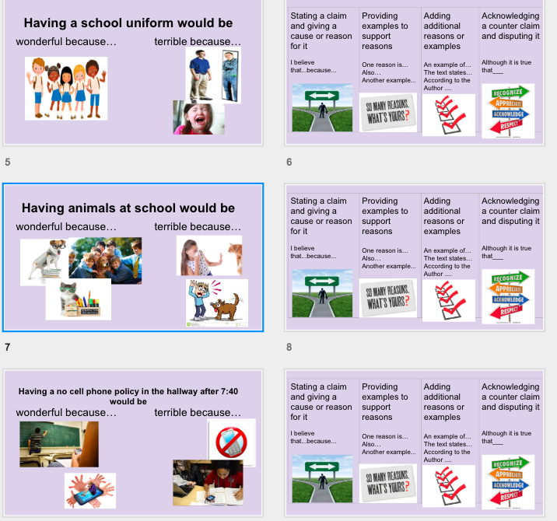
*Sentence starter display created by Sarah Woods.

