Craig Lawson
Arts with the Brain in Mind
Assign. 17-A Lesson Development
Lesson Plan 8/13/18
Pulled String/Technique
Class: Art 101
Time: Scheduled period - for 1 week
Grade: 6-8
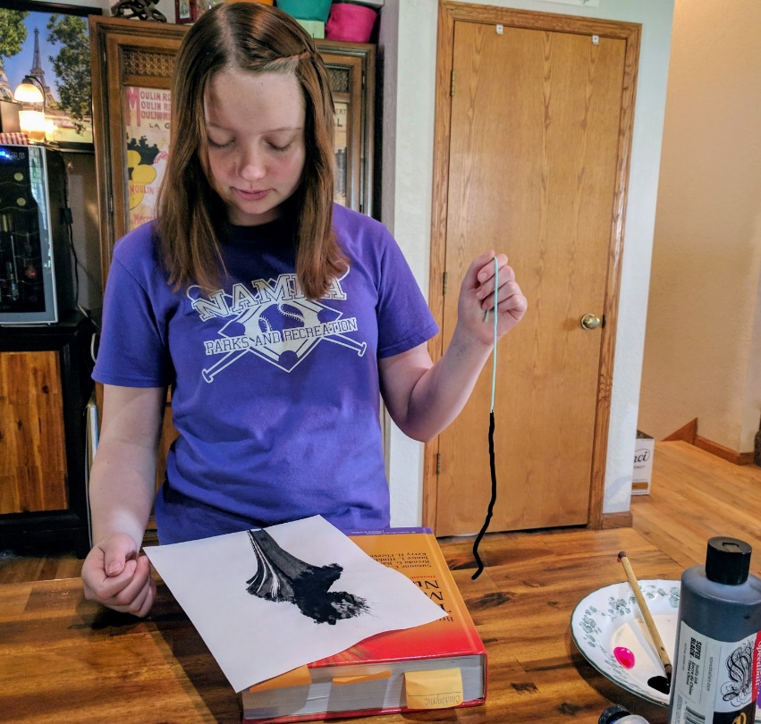
Art Concept: Pulled String Technique
Objective:
- Allow students to get to know what images are possible with this technique by showing images (from archives of previous student work) on smart-board of what a piece looks like before the string is dipped into the ink or paint, then what the image looks like after string has been pulled.
- Students will be able to use the paint or ink-pulled-string technique to make a highly unique piece of art.
- Encourage overwhelmed students and reduce their confusion by first demonstrating the technique step-by-step to result in a finished product. Teachers will need to practice this technique on their own to work out all possible kinks and to help the lesson run smoothly the first time.
- Answer any questions that may come up about what we will be doing by referring to power point archives or put on the referenced youtube videos.
- Develops hand eye coordination and fine motor skills.
- Introduces and reinforces known and previously unknown techniques and art-related vocabulary words.
Materials & Tools list:
8.5” x 11” sheet of white cardstock or (16” x 20”) watercolor paper or white gessoed canvas (16” x 20”)
Gouache paint (primary colors/various color tubes of your choice)
OR tempera paint (primary colors/various colors-to be used on paper, cardstock or watercolor paper only)
OR Student grade acrylic paint (primary colors/various colors--to be used on canvas only)
String or twine cut into 12” to 24” lengths
Super-Black India ink bottle (such as Dick Blick Black Cat, Super-Black waterproof India ink)
Heavy books that you don’t mind if paint or ink sticks to, or gets on, such as phone books
Paper towels
Hair dryer
Aprons
Popsicle sticks
Begin with step by step instructions
Demonstrate fully, the steps below for students.

- First, create an area in the room for the messiest steps of the project. Flatten the surface of your watercolor paper, white cardstock (you will not be needing to flattening the gessoed canvas; the canvas alternative to this project would be similar in steps. For acrylic on gessoed canvas tips, see referenced youtube video.)
- Accomplish your idea using the hints from the tutorial videos from youtube - (in resources). Encourage students to use the whole picture plane. (The entire area of the paper, or canvas surface.)

- Fold your picture plane of choice in half (not the gessoed canvas) i.e. the watercolor paper, or white cardstock. Open your folded piece, lay it flat.
- Begin dipping your string into a bottle of ink or a plate with the acrylic paint or ink of your chosen colors, poured out onto it. You may need to use a popsicle stick, to submerge the string as you dip, depending on how thick or thin your ink or paint is.
- When the ink or paint is soaked into your string, pull it slowly out of the puddle or bottle, being careful not to let it drip onto the surface of your picture plane. If this happens, there’s no need to worry, the image may be fine and this technique will make you want to do many more, until you become an expert at hovering over your paper with a wet string with no drips in sight.
- Next begin lowering the string down onto the surface of your picture plane. Carefully let the string loop over itself as you lay it down. Ensure that the dry end of the string by your hand ends up near the edge of you paper if not completely off the edge.
- Now you are ready to place another piece of paper on top of the whole area (if you want only one image on your paper you would do it as suggested above.---If you want a mirror image of the pulled string -- that is two unique images -- you would close your folded sheet overtop of the string.) Press firmly but not too firmly (alternatively you would use the weight of a sacrificial book such as a phonebook to apply even pressure.)
- Slowly begin pulling the string out from between the layers of your picture plane. Remove book and unfold the folded paper.
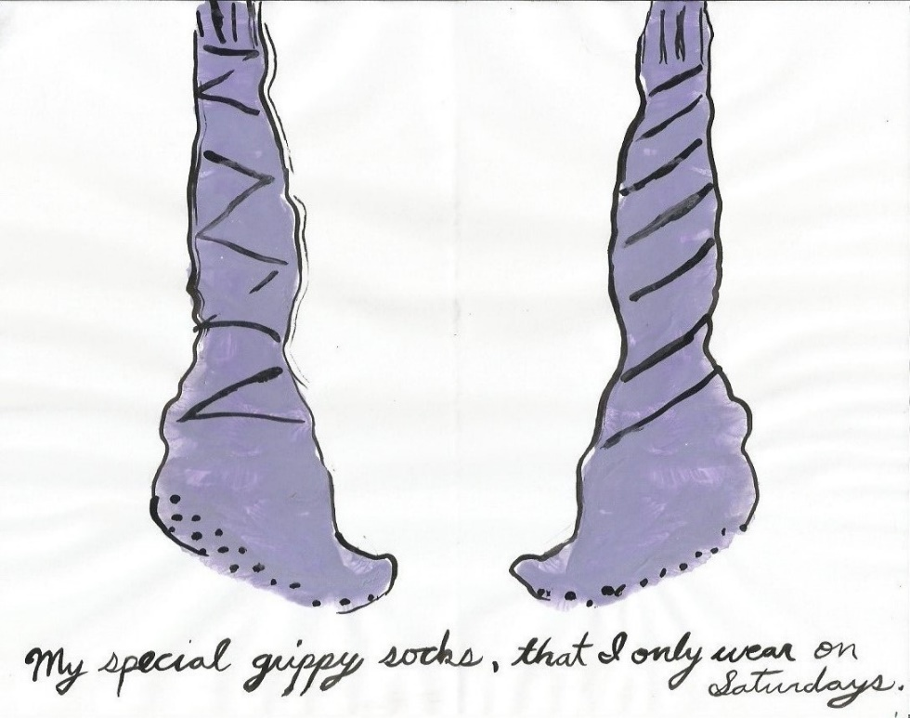
- Lay flat to dry completely. To speed things up, use a hair dryer.
- When dry, place your artwork flat on your table. Add detail with pen and ink or with a fine/small brush, to your liking but be creative. Maybe you can see something in the shape? Keep your mind open as you rotate the image.

- When the details are to the level you prefer, let dry again.

- Warm iron as needed to remove wrinkles (necessary on paper and cardstock only).
An image created by my daughter of her special winter socks she calls Grippy’s
Student Assessment / Participation:
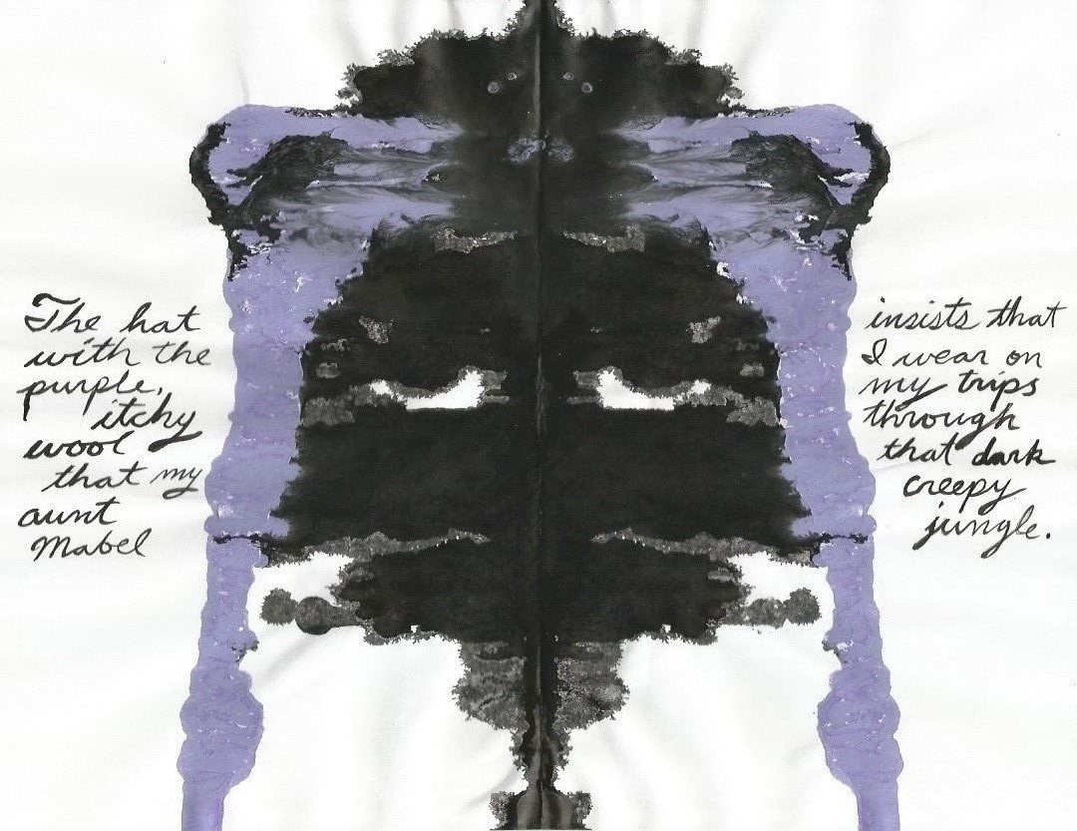
The students’ art pieces will be assessed not by the quality of the finished image; (this idea is subjective in nature and grading such, would be unfair based on varying skill levels of all students in a given class; assessment would be extremely difficult.) grading should be assessed more by the accomplishing of the steps in proper order. Missing any steps, or steps out of order would make the image difficult to see as a result. I included a vocabulary list that you can go over formally or informally as you see fit. I gave my student the quiz and watched her squirm a bit. She has been in art classes in her Arts Charter school since the 3rd grade and as she’s going into 9th grade this year, she knows a lot of the list, but some words were tricky for her. This tells me that it’s a challenging enough list to implement a quiz for this grade level.
My 14 year old Abbey created a girl in a nit winter cap for her Pulled-String Art piece. She named it My Itchy Hat.
__________________________________________________________________________

Variations:
The variations of this lesson are more based on materials (i.e. cardstock or watercolor paper or canvas – gouache or tempera paint or acrylic paint) and not the overall execution of the steps. The process should be as-it-reads, in the step by step guide of this lesson. Teachers, you should practice this technique on your own at first to work out any kinks before trying to implement the lesson in your class for the first time.
______________________________________________________________________________
Resources:
https://youtu.be/UcBV0B3TwdE?t=69
https://youtu.be/cQx1zQJ6Du4?t=359
https://youtu.be/HMhVXDYEqsA?t=202
https://youtu.be/0bWsrJFsYDo?t=159
www.dickblick.com
This Art lessons’ Vocabulary Words

Acrylic / Add / Archive
Black / Bleed
Board
Canvas / China
Concept / Create
Cardstock
Dark / Demonstrate
Dense / Detail
Develop
Drawing / Dry
Gel Medium
Gesso / Gessoed
Hair dryer
Image
India ink
Materials
Matte
Media / Medium
Monochrome
Opaque
Painterly
Picture-plane
Pigment
Primary
Revealed
Scratch / Sketch
Supplies
Surface
String/Twine
Technique
Tempera
Tertiary
Translucent
Transparent
Unique
Watercolor
Waterproof
Wet
White

