Cold War Expose and Engage Day
Subject/Course: World History
Topic/Unit: Unit #8-The Cold War
Lesson Title: Cold War Expose and Engage Day
Level: 10th Grade
Duration: One Monday 50 minute period.
Objectives:
- Students will develop a deeper interest and understanding of the Cold War era.
- Students will be able to compare and contrast the difference between a cold and hot war.
- Students will be able to identify manifestations of the Cold War through art, music, film, sports, and fashion. They will be able to see how the Cold War affected society and how outlets like music and sports affected the Cold War.
Tasks:
- As the passing period goes on, play Cold War era songs for students to enter the class with.
  - Recommended: Billy Joel-We Didn’t Start the Fire
Sting-Russians
Tears for Fear-Everybody Wants to Rule the World
The Beatles-Back in the U.S.S.R.
- Have a stimulus/conversation question projected on the board for students to discuss with their partner for the first minutes of class. Music can keep playing in the background.
  - Question: Why was the Cold War called a “Cold War”?
    - Things to consider: Was it fought primarily in the U.S.S.R.?
Was it fought over winter?
What is the difference between cold/hot war?

  - Discussion: Termed a Cold War because the two major world powers (U.S.S.R. and U.S.A.) didn’t fight directly against each other. Briefly discuss examples such as Korea, Vietnam, and Cuba to give insight to future lessons.

- Start the Cold War Expose and Engage PowerPoint. Visit the relevant links to access the extra videos, etc. Distribute and collect the Fashion Handout as directed in the PowerPoint. This PowerPoint is designed to gain most students’ attention by covering the Cold War era through music, art, TV, fashion, sports, etc.
  - Make as many relevant connections as possible and facilitate the conversations to guide them to important and interesting observations connecting their lives to the Cold War era.

- Assign the Extra Credit Opportunity for this unit/end of semester (End of slideshow).
  - Play both previews to gain interest.

Fashion Handout
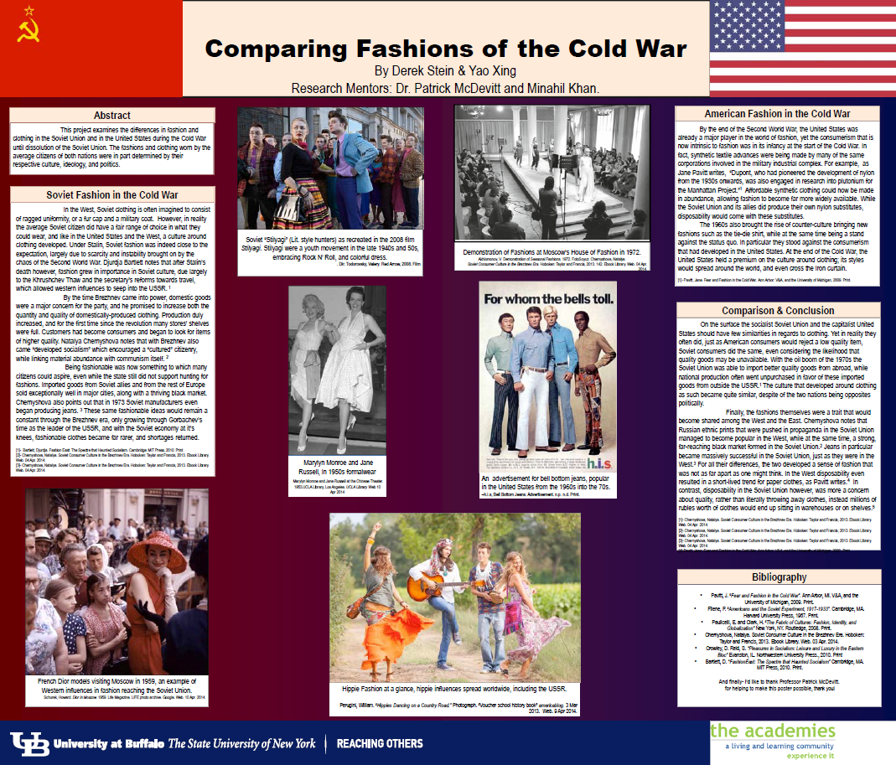

PowerPoint
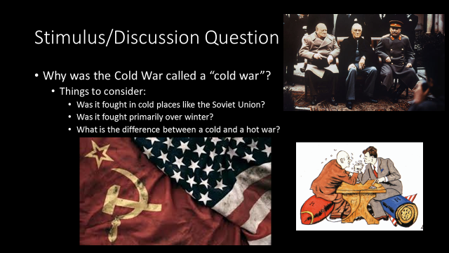
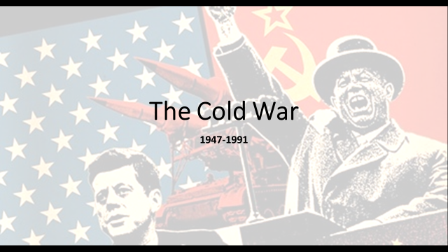
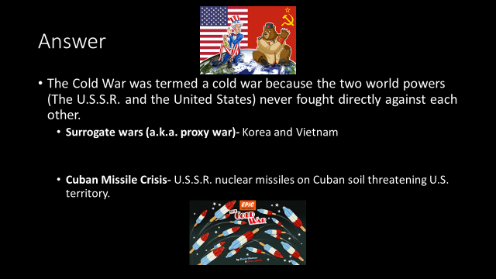
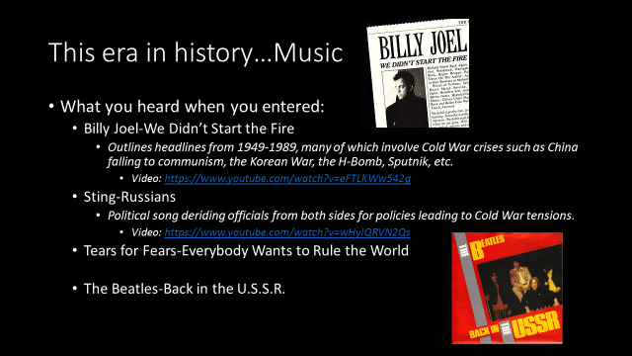
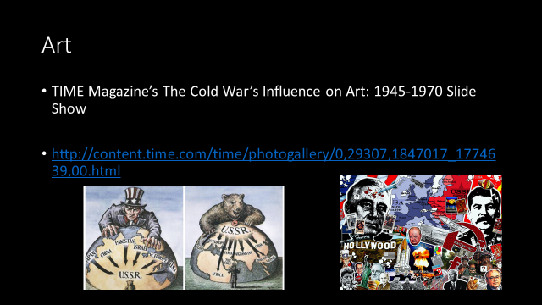
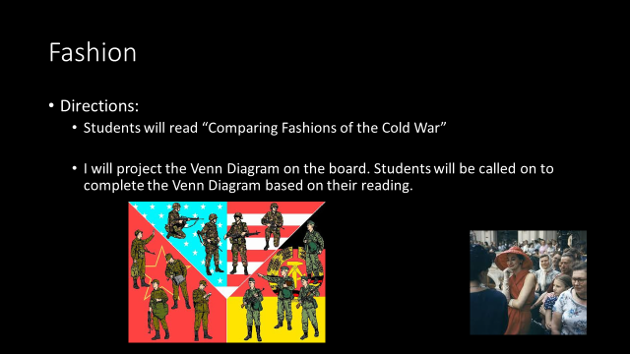

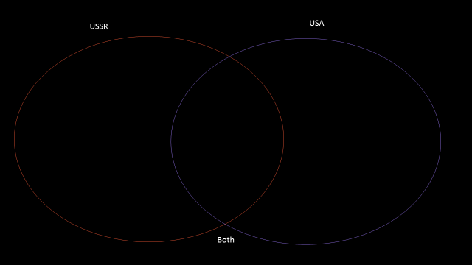
15
