Adam Gaede
4-20-18

Assignment #10: Lesson Plan Creation

Lesson Title:
Literature Circle with The Help (by Kathryn Stockett)

Students:
6th Grade: assigned to small groups for higher readers

Time:
According to teacher discretion so that students have time to read the entire novel with time to complete and prepare work for six different discussions. I scheduled approximately one lit circle discussion time per week and offered class time for reading and preparation, so the whole project was spread out over about 5 weeks.

Learning Goals / Essential Questions:
How can you successfully share and enjoy a reading experience with your peers?
How does the author help readers navigate and understand the power dynamics as they pertain specifically to race and sex?

Common Core Standards:
Reading, Literature
6.RL.1 Cite textual evidence to support analysis of what the text says explicitly as well as inferences drawn from the text.
  - 6.RL.2 Determine a theme or central idea of a text and how it is conveyed through particular details; provide a summary of the text distinct from personal opinions or judgments.
  - 6.RL.3 Describe how a particular story’s or drama’s plot unfolds in a series of episodes as well as how the characters respond or change as the plot moves toward a resolution.
Speaking and Listening
6.SL.1 Engage effectively in a range of collaborative discussions (one-on-one, in groups, and teacher-led) with diverse partners on grade 6 topics, texts, and issues, building on others’ ideas and expressing their own clearly.
    - Come to discussions prepared, having read or studied required material; explicitly draw on that preparation by referring to evidence on the topic, text, or issue to probe and reflect on ideas under discussion.
    - Follow rules for collegial discussions, set specific goals and deadlines, and define individual roles as needed.
    - Pose and respond to specific questions with elaboration and detail by making comments that contribute to the topic, text, or issue under discussion.
    - Review the key ideas expressed and demonstrate understanding of multiple perspectives through reflection and paraphrasing.

Activity / Procedure:
Lit Circle Packets are provided outlining the students’ reading and work schedule and also detailing the jobs that rotate throughout their reading experience. The packets are long and involved, but for the sake of this assignment, I will include TWO of the four different jobs that students will complete over the course of the time. Every student will complete each of the four jobs at least once, and it is delineated so that during each lit circle session (day), every job will be presented so that the whole novel is analyzed for all four jobs: Characterization Contributor (CC), Imaginative Illustrator (II), Empathy Enforcer (EE), and Power Prober (PP). Below are the job descriptions for EE and PP included in each students’ packet.

Empathy Enforcer (EE)

Your job is to patrol the reading for three moments when any character acts, feels, or thinks with empathy, and/or when you as a reader feel empathy for any character. If you never discovered any evidence or feelings of empathy, instead find moments when one character could have or should have showed empathy for another character.

During Reading
For each of the three examples of empathy, briefly describe and summarize the event (including the page number in parenthesis), and then write a short reflection that shares your thoughts, opinions, and ideas about that empathy moment. Each of your three moments should be at least 3 sentences, meaning that your total writing should be at least 9 sentences.

Presentation
Begin by asking your group if they can think of any examples from the reading that demonstrate one or more characters’ empathy. Please allow them at least 30 seconds of think time, and then invite volunteers to express their ideas.
Next, read your first moment. After each example and your explanation (one at a time), allow time for your group members to discuss your idea and their ideas about your idea! Continue with your last two examples.

Power Prober (PP)

Your job is to probe for at least three examples where the concept of power has been explored by the author. How does this reading help us readers think about how power is used and how different characters possess different amounts of power? Though these novels celebrate black characters, you are not limited to discussing only racial issues, though you must have at least one strong example that explores power due to one’s racial identity. Other categories could include:
- age
- sex
- gender
- financial / economic
- social
- body

During Reading
When you discover a strong example, write down its location and a one-sentence summary of that incident. In your next three sentences, explain your thinking about this and analyze how the power impacted the example. You are welcomed to also share your opinion and even an alternate solution to what happened. Repeat this process two more times, resulting in 3 total paragraphs each with 4 sentences.

Presentation
During the lit circle, you will begin by locating the text and providing your one-sentence summary of that example. Then allow your group members to discuss their opinions and thoughts. Once everyone has shared, please read your prepared paragraph, and then allow your group to discuss your writing before you move on to your next examples.

Assessment:
Using a chart provided and full consensus, students self-assess each individual from their group, judging the preparation of their job as well as factors relating to the success of the actual discussion (ex. participated in discussion, listened thoughtfully to others’ ideas, focused on task, etc.). Points were awarded toward their grade for the prepared work (ex. EE or PP) as well as for their role during the discussion.
I have discovered that students are even more motivated when they know their peers are judging their efforts and that the consensus process is designed for fairness. They learn from their discussion about the self-assessment what they did well and upon what they could improve. At the end of the discussion and the self-evaluation, each student also writes a reflection about that day’s experience. These are all included in the packet.

Reflection:
My students absolutely loved discussing this book because they loved the novel but they also really bonded during the experience. They were enthralled at reading an adult book with more hints at mature content, and they also appreciated seeing all the micro, macro, personal, and systemic examples of racism and sexism layered throughout. This synthesized so much of our other learning and class activities around race in America this winter.
This literature circle group (The Help), and my other groups who read different books, also enjoyed a culminating party after they completed all six literature circles: a dinner and movie viewing at one of the family’s house. They loved this fun event and how it mirrored the reality of an adult book club in that it was a special social shared experience.

Examples:
Below are some examples of student work during the literature experience.
Empathy Enforcer
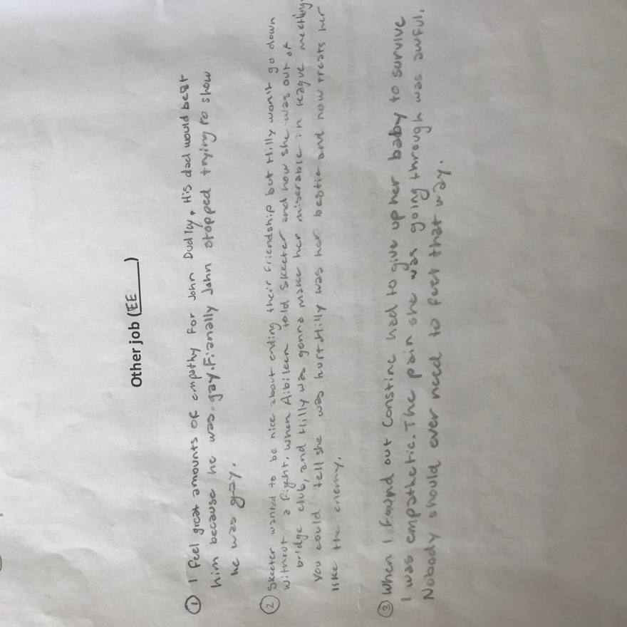

Power Prober
