Assignment 6
This is the beginning of my Fractions Unit. Because this is my largest domain and there are many skills involved and all these skills have to be mastered, I would like to start off with reviewing GCF, LCM and reducing fractions. I think that this review will be necessary and helps students have success when we are adding and subtracting fractions with unlike denominators.

Day 1
Factors and Multiples - Diane Zeitzheim
Grade 5
Essential Question How do I find factors and multiples?
Students will understand the relationship between factors and multiples, and determine whether a number is a multiple of a given number.
Smart Board, dry erase boards and computers

- Morning Work: Individually
watch Khan Academy videos (posted on Google classroom)
- Finding Factors of a Number https://www.khanacademy.org/math/pre-algebra/pre-algebra-factors-multiples/pre-algebra-factors-mult/v/finding-factors-of-a-number
- Finding Factors and Multiples
https://www.khanacademy.org/math/pre-algebra/pre-algebra-factors-multiples/pre-algebra-factors-mult/v/finding-factors-and-multiples

- Review multiples and factors - SmartBoard file (see below)
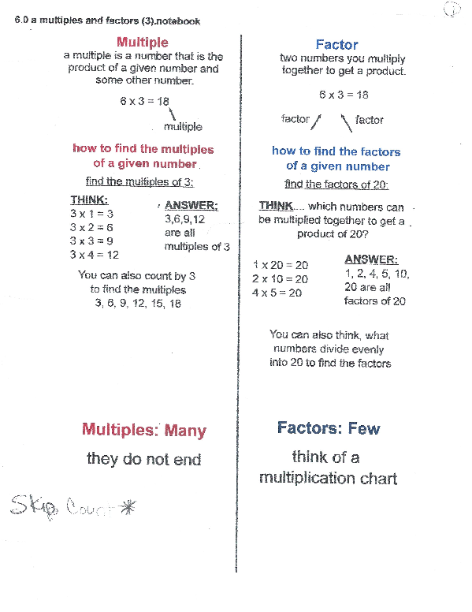
Go through and discuss the difference between multiples and factors. *****Remind students that when finding multiples to skip count and when finding factors to create a factor ladder. *****

3. Factors and multiples intro (use for any absent students or for extra review)
https://www.khanacademy.org/math/pre-algebra/pre-algebra-factors-multiples/pre-algebra-factors-mult/a/factors-and-multiples

4. Practice (whole class)
Using dry erase boards, find the LCM and GCF of various numbers
For example: 6 and 8

LCM 6 6, 12, 18, 24, 30 LCM = 24
8 8, 16, 24

GCF 6 8 GCF = 2
1 6 1 8
2 3 2 4

5. Continue this practice at their seats. Also have students work in partners to find the GCF and LCM. Check their work.

6. Assign practice - Khan Academy: individually
- Factor Pairs https://www.khanacademy.org/math/pre-algebra/pre-algebra-factors-multiples/pre-algebra-factors-mult/e/factor-pairs
- Identify Factors and Multiples
https://www.khanacademy.org/math/pre-algebra/pre-algebra-factors-multiples/pre-algebra-factors-mult/e/identifying-factors-and-multiples

Day 2
Finding GCF and LCM - Diane Zeitzheim
Grade 5
Essential Question: What is the difference between GCF and LCM?
Students will be able to identify the GCF and LCM for a given set of whole numbers
Smart Board, dry erase boards and computers

- Continued practiced finding GCF and LCM
  - Begin whole group and using smart board and dry erase boards, have students find the GCF and LCM of various numbers.
  - Continue this with partners
  - Continue this individually, have students hold up boards to check answers.

2. Practice - Khan Academy: individually
- Least Common Multiple Practice
https://www.khanacademy.org/math/pre-algebra/pre-algebra-factors-multiples/pre-algebra-lcm/e/least_common_multiple
b. Greatest Common Factor Practice
https://www.khanacademy.org/math/pre-algebra/pre-algebra-factors-multiples/pre-algebra-greatest-common-divisor/e/greatest_common_divisor

3. Continue to monitor individual students by calling them in small groups to back table and have them find the GCF and LCM of certain numbers.

Day 3
Reducing/simplifying fractions - Diane Zeitzheim
Grade 5
Essential Question: How to simplify fractions by finding the GCF and using divisibility rules?
Students will be able to simplify fractions by dividing numbers into the numerator and denominator that follow the divisibility rules.

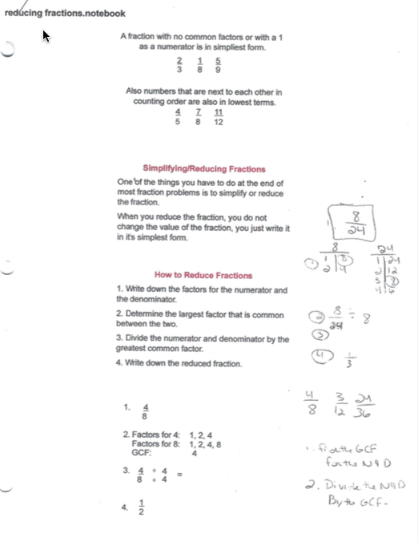
￼￼1. Review reducing/simplifying fractions with SmartBoard file (see below)

2. Practice - whole group
Students will use their dry erase boards and we will do some together, explaining each step (math talk). Have students move to working in pairs, then individually.

3. Assign Practice - Khan Academy: individually
- Simplify Fractions https://www.khanacademy.org/math/arithmetic/fraction-arithmetic/arith-review-visualizing-equiv-frac/e/simplifying_fractions

4. Leveled Practice - Simplify Fractions WS
This is a self-paced activity. I have three worksheets that start out very simply and continue to an advanced level. The students will work at their own pace to complete these. I run them off on different colors so it is easier to see where the students are. They will also self-check before checking in with me. If they have “mastered” a level, I will move them on.
- Level I: simple fractions, all with a known common factor.
- Level II: larger fractions, where students will have to find the common factor.
- Level III: all fractions are in the hundreds, students will have to find common factors.
Students tend to like this self-paced activity. I have done this will other skills.

