Assignment 7

Day 1
Introduction to Adding Fractions with Unlike Denominators - Diane Zeitzheim
Grade 5
45 minute class
Essential Question: How can you add fractions with unlike denominators? To add fractions the denominators must be alike. All fractions must be simplified and/or reduced into lowest terms. During the process of adding, the operation is applied to the numerators only and denominator remains the same.
Learning Goal: Can students learn how to correctly add fractions with unlike denominators?
5.NF.1 Add and subtract fractions with unlike denominators (including mixed numbers) by replacing given fractions with equivalent fractions in such a way as to produce an equivalent sum or difference of fractions with like denominators.
Materials: Smart board, dry erase boards, computers

- Morning Work: watch Khan Academy video (posted on Google classroom)
Add Fractions with Unlike Denominators
https://www.khanacademy.org/math/cc-fifth-grade-math/cc-5th-fractions-topic/modal/v/adding-small-fractions-with-unlike-denominators

2. Model the Skill - Smartboard File (see below)
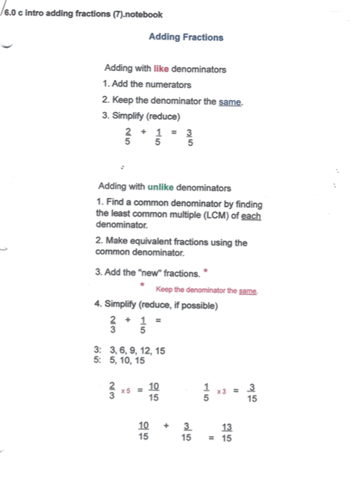

3. Practice the Skill: using dry erase boards, practice adding fractions with unlike denominators together. Using our “math talk”, have students explain each step.

For Example:
- ⅓ + ½
- Find the LCM of 3 and 2 = 6
- Create 2 new fractions using the LCM
- Remember: “Whatever we do to the bottom, we have to do to the top!”
- 2/6 + 3/6 = ⅚
- This cannot be reduced because they are next to each in counting order. It is in lowest terms.
Do several of these with the whole class, move to partners, then individually. Move around the round to ensure students are completing the steps and answering correctly.

4. Assign: Practice Add fractions with unlike denominators
https://www.khanacademy.org/math/cc-fifth-grade-math/cc-5th-fractions-topic/tcc-5th-add-sub-fractions/e/adding_fractions

Day 2
Introduce Subtracting Fractions with Unlike Denominators - Diane Zeitzheim
Grade 5
45 minute class
Essential Question: How can you subtract fractions with unlike denominators? To subtract fractions the denominators must be alike. All fractions must be simplified and/or reduced into lowest terms. During the process of subtracting, the operation is applied to the numerators only and denominator remains the same.
Learning Goal: Can students learn how to correctly subtract fractions with unlike denominators?
5.NF.1 Add and subtract fractions with unlike denominators (including mixed numbers) by replacing given fractions with equivalent fractions in such a way as to produce an equivalent sum or difference of fractions with like denominators.
Materials: Smart board, dry erase boards, computers

- Morning Work: watch Khan Academy video (posted on Google classroom)
Subtract Fractions with Unlike Denominators
https://www.khanacademy.org/math/cc-fifth-grade-math/cc-5th-fractions-topic/tcc-5th-add-sub-fractions/v/subtracting-small-fractions-with-unlike-denominators

- Review Adding Fractions with Unlike Denominators
Write a problem on the smart board, have the students individually solve it on their dry erase boards. When completed, they will turn boards over until all are done. Then, the students will show their answers. We will discuss the steps and I will answer any questions the students have.

3. Model the Skill - Smartboard file (see below)
This is just like adding with unlike denominators, EXCEPT watch the operation. Begin explaining that the first thing you notice is that this is a subtraction problem. It is very common for students to complete a problem doing the wrong operation!
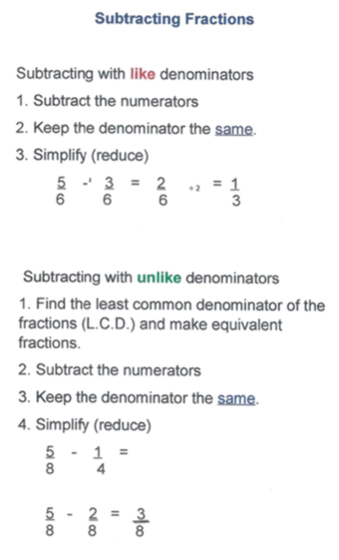

4. Practice the Skill: using dry erase boards, practice subtracting fractions with unlike denominators together. Using our “math talk”, have students explain each step.

For Example:
- ¾ - ½
- Find the LCM of 4 and 2 = 4
- Create 2 new fractions using the LCM
- Remember: “Whatever we do to the bottom, we have to do to the top!”
- ¾ - 2/4 = ¼
- This cannot be reduced because when the numerator is a one, the fraction is in lowest terms.
- Also remind students that in some problems, one of the fractions may contain the LCM, so there is no change to that one fraction.
Do several of these with the whole class, move to partners, then individually. Move around the round to ensure students are completing the steps and answering correctly.

5. Assign: Practice Subtract fractions with unlike denominators
https://www.khanacademy.org/math/cc-fifth-grade-math/cc-5th-fractions-topic/tcc-5th-add-sub-fractions/e/subtracting_fractions

Day 3
Continued Practice with Adding and Subtracting Fractions with Unlike Denominators - Diane Zeitzheim
Grade 5
45 minute class
Essential Question: How can you add and subtract fractions with unlike denominators? To add and subtract fractions the denominators must be alike. All fractions must be simplified and/or reduced into lowest terms. During the process of adding and subtracting, the operation is applied to the numerators only and denominator remains the same.
Learning Goal: Can students learn how to correctly add and subtract fractions with unlike denominators?
5.NF.1 Add and subtract fractions with unlike denominators (including mixed numbers) by replacing given fractions with equivalent fractions in such a way as to produce an equivalent sum or difference of fractions with like denominators.
Materials: Smart board, dry erase boards, computers

- Morning Work: practice on IXL adding and subtracting fractions with unlike denominators. Work towards a smart score of 100.
https://www.ixl.com/math/level-h/add-and-subtract-fractions-with-unlike-denominators

2. Continued Practice: have the students work on adding and subtracting proper fractions two-sided WS. The first side is considered “easy” while the back side is moderate level. As students finish, they may find a partner to check their work. If they both have the same answer, we consider that correct. If they answers differ, they need to do a math talk and discuss which one they consider is correct and why. They need to prove to their partner why they think their answer is correct. We have done this before, so they know the procedure. If they can’t agree, they come to me to work the problem out.
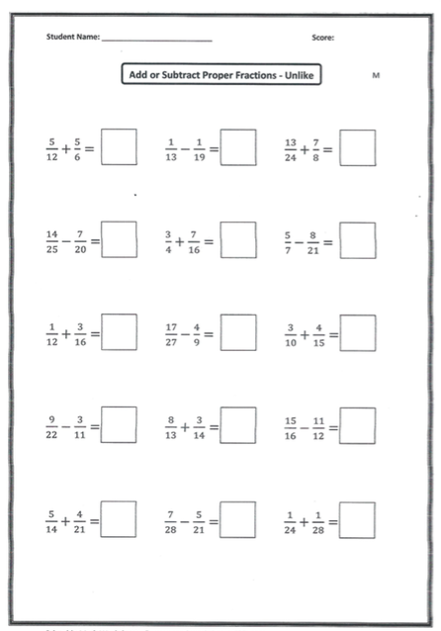
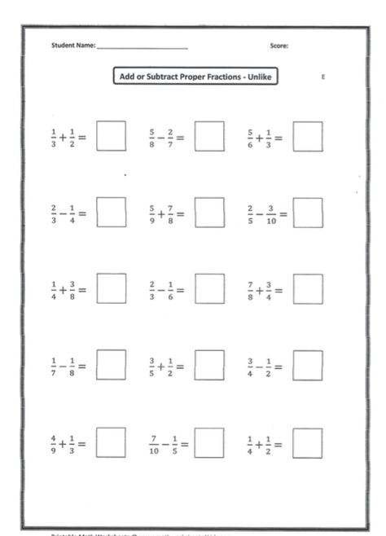

3. Assign: Add and Subtract Fraction Challenge
https://www.khanacademy.org/math/cc-fifth-grade-math/cc-5th-fractions-topic/tcc-5th-add-sub-fractions/e/adding-and-subtracting-fractions-with-unlike-denominators

