Title: Building a Function
By Kress Drew
Grade Level: 9-12
Subject: Algebra II
Preparation and Materials: One set of cards is included at the end of this lesson plan. Copy and cut them out, one set for each group of two students. Organize your class list into groups of two students and provide a work space for each group to work together in, perhaps pulling two desks together, etc. NO GRAPHING CALCULATORS ALLOWED.
Goal: Given a polynomial function, for you to be able to:
- State the leading coefficient and the degree
- Determine the left and right end behavior of the graph.
- State the maximum number or times the graph intersects the x-axis
- Draw an approximate sketch of the graph
Common Core State Standards
F.IF.4: For a function that models a relationship between two quantities, interpret key features of graphs and tables in terms of the quantities and sketch graphs showing key features given a verbal description of the relationship.
F.IF.7.c: Graph polynomial functions, identifying zeros when suitable factorizations are available and showing end behavior.
Background: This activity will be done as part of the second day of working with polynomial functions. On the first day of class students: reviewed the basic concepts of functions, including: it’s leading coefficient and it’s degree. After this review, students were introduced to: how to determine the function’s left and right end behavior, how to determine the maximum number of times the graph crosses the x-axis, and how to draw an approximate sketch of the function.
The Activity: In this activity students will be put into groups of two and then given a set of cards. Within the set of cards, each card will state a characteristic of a polynomial. Things like: the left behavior, the right behavior, the degree of the function, a sketch of the function, etc.
When students begin the activity they will first mix up the cards and place them all face up in front of them. They will be given 1 minute to silently look through the cards and examine what is before them. Next they will be asked to share with their partner some of their observations.
Afterwards the bulk of the activity will take place. One student will select a card and place it in an open area to begin building a correct function. Then the partner will select a card. Explain why they are choosing it and how it relates to the first selected card. Then they will place it next to the first card. The other partner can agree or disagree. If they disagree they need to come to a reasoned conclusion and either stay with the original card or replace it with another. If they replace it, the partner who first selected the card must choose the replacement. (This will avoid one person doing all the work.) After they discuss and agree upon the second laid card, whether a change in card two took place or not, then the first partner will select again and they will continue the discussion and agreement process each time a new card it laid down. They will continue to rotate selecting cards until all seven cards are laid down for the first function.
Next they will begin a new function from the remaining cards, this time the other person will select the first card and they will rotate back-and-forth between partners as they did before. The only new requirement is the group must select a different first card. Therefore if they started with the right behavior card in the first lay down, then they must start with any other card but the right behavior the second time they build the function. This will create a natural flexibility into the activity and allow the students to see the function from a different perspective then the previous laydown.
Each set of cards has enough cards to build four accurate functions and have one set of seven cards left over that do not combine together to make an accurate function. This will ensure each group will be able to have each partner start twice and not be able to have the last function solve itself after the third function is completed.
During the activity I will walk around monitoring the various groups, listening to the discussions and asking leading questions of each of the partners. This will allow me to look for common strengths and weaknesses within the overall class, which will provide me with a better understanding of areas of group mastery and areas of entire group need.
When the students are finished I will ask them to reflect upon what they have learned throughout the activity. They will be given time to privately reflect and then share with their partner. Each partner will then be asked to write down one area of growth from the activity and one area of confidence they have gained by taking part in this activity. If there is time within the period, I will have two groups interchange their partner with another group, and have the new partners from each group join together and share their thoughts and observations with each other.
Conclusion: I believe this activity will give each student support where it is needed and the opportunity to demonstrate their current strengths in working with functions and their behaviors. Along with this, it will allow them to process and grow and not feel threatened as they strengthen their understanding by participating in this matching game-like activity
. Cards
Y = .125x^3 + x^2 -3x + 1 | Right side goes down
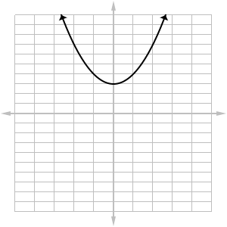 | 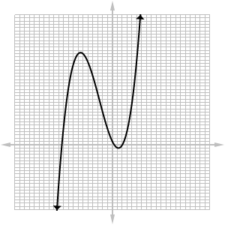
Left side goes up | Crosses the x-axis three time
Degree is 3 | -.125 is the leading coefficient
Y = x^2 + 3 | Right side goes up
Left side goes up | Crosses the x-axis zero times

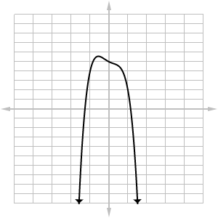 | 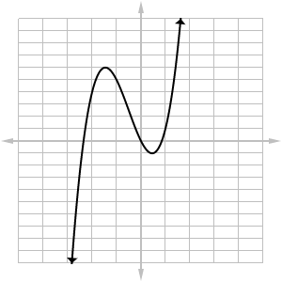
Degree is 2 | 1 is the leading coefficient
Y = -3x^4 + x^2 – x + 5 | Right side goes down
Left side goes down | Crosses the x-axis two times
Degree is 4 | -3 is the leading coefficient

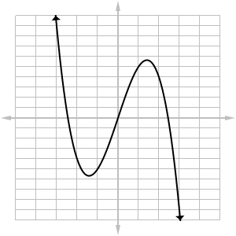
Y = 2x^3 + 3x^2 –x -4 | 2 is the leading coefficient
Degree is 3 | Crosses the x-axis three time
Left side goes down | Right side goes down
Degree 7 | Right side goes up

Left side goes up | Crosses the x-axis 4 times
10 is the leading coefficient | Y = (1/4)x^10 + x^2 - 5

