Craig Lawson
Classroom Management That Works
Assign. 14-A Lesson Development
Lesson Plan 7/31/18
Ink Resist/Floatation
Class: Art 101
Time: Scheduled period - for 1 week
Grade: 6-8
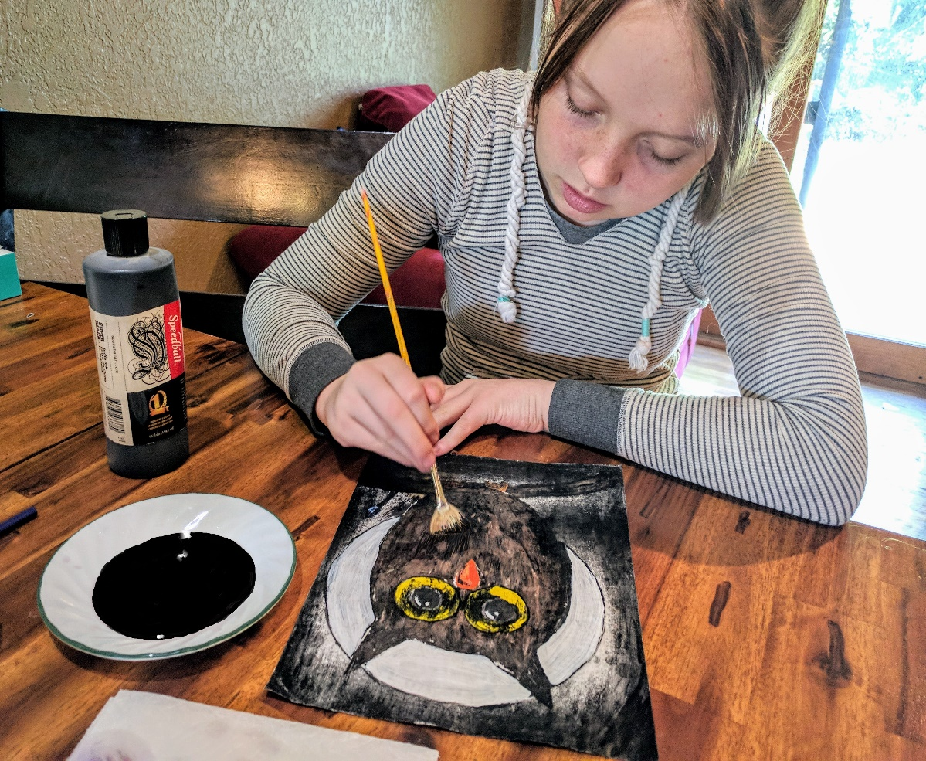
Art Concept: Ink resist
Objective:
- Allow students to get to know what images are possible with this technique by showing images (from archives of previous student work) on smart-board of what a piece looks like before the ink wash, then what the image looks like after ink wash and rinse.
- Students will be able to use paint and an ink wash techniques to make a highly unique piece of art.
- Encourage overwhelmed students and reduce their possible anxieties by first demonstrating the technique step-by-step to result in a finished product. Teachers will need to practice this technique on their own to work out all possible kinks and to help the lesson run smoothly the first time.
- Answer any questions that may come up about what we will be doing by referring to power point archives.
- Develops hand eye coordination and fine motor skills.
- Introduces a brief history of this unique technique.
- Introduces and reinforces known and previously unknown art-related vocabulary words.
Materials & Tools list:
8.5” x 11” sheet of white cardstock or (16” x 20”) watercolor paper or white gessoed canvas (16” x 20”)
Pencil / kneaded eraser
White tempera paint or white Gouache (tube)
One dark colored - watercolor paint tube (your choice of color)
Sable brushes, or student grade watercolor brushes and polyurethane foam brush or sponge
Super-Black India ink bottle (such as Dick Blick Black Cat Super-Black waterproof India ink.)
Student grade acrylic paint
Water (from classroom sink. Sink access a necessity)
Paper towels
Hair dryer
Aprons
Begin with step by step instructions
Demonstrate fully, the steps below for students.

- First, using a pencil, sketch your image onto the surface of your watercolor paper, white cardstock or gessoed canvas. Think about what areas you want to leave white and those that you wish to be dark. Accomplish your drawing using the hints from the tutorial videos from youtube - (in resources). Encourage students to use the whole picture plane. (The entire area of the paper, or canvas surface.)

- Dye your white gouache with a glob from the dark watercolor tube by mixing with a brush. Stain it dark enough to be able to see it on the watercolor paper, white canvas or white cardstock when it is painted onto the surface.

- Next, paint thickly onto your drawing with the gouache mixture, everything you want to stay white. Hint when painting, think of the reverse of your image; what will be the black of the India ink, is what I am not going to paint. Remember to paint thickly enough to resist the ink in these areas that are remaining white. Teachers should check that all students have painted their layers thick. If necessary drying time can be added between the layers of the gouache or tempera paint.

- Lay flat to dry completely. To speed things up, use a hair dryer.

- Next step. While working flat, use the sponge brush and the India ink to create a wash over the whole picture plane, being sure to cover everything completely with the ink. Aprons will be necessary for this step.

- Allow to dry completely. Again, use hair dryer.

- When dry, place your art piece in a sink and use a sprayer nozzle-(if available) to carefully remove the ink from the surface by light brushing with a soft sponge brush and light force of the water; alternatively you can gently use the palm and fingers of your hands. The painted areas will resist the ink. These areas of slight color will wash away, (don’t be concerned, this is the desired effect) and your gouache painted areas and details will be revealed. The inked areas have stained the canvas, or watercolor paper or cardstock.

- When the details are to the level you prefer, remove from sink and lay flat to dry. Warm iron as needed to remove wrinkles (necessary on cardstock only).

- Speed it up already! Use your hair dryer…

- When dry, lay flat and begin filling in the white areas with acrylic paint color washes, per your liking, build up the color in glazes (do not work too thickly or opaquely; these glazes should always be transparent or translucent, as in past acrylic assignments). In this way your ink resist painting will achieve a unique look. Be careful not to completely cover opaquely, with color, all of the black inked in areas as these areas are part of the uniqueness of the final piece.

Background Information:
Inks:
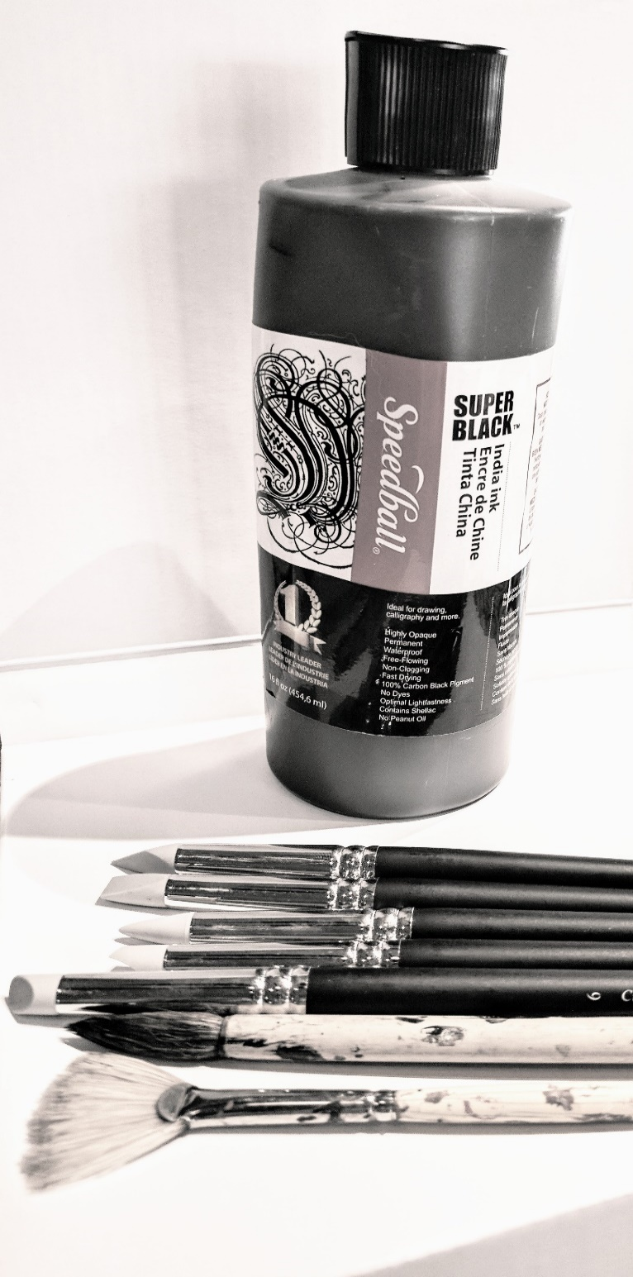
Drawing ink first appeared in China, (year 3,000 BCE). This early ink was a combination of pinewood smoke, lamp oil, and gelatin from animal skins. Next, about 400 CE, a new ink formula began to be used, incorporating ferrous sulfate (produced from iron and sulfuric acid), tannin (produced from gall-nuts) and a thickener. Since then, art inks have been made from a diversity of sources, ranging from sooty carbon based materials (bistre - a very dark shade of grey) to dyes derived from berries, oak galls, insects, Cuttlefish - phylum, Mollusca - order, sepiida - class, cephalopod with defensive ink), and crustaceans. Only black and white inks are permanent, as other inks contain soluble dyes rather than pigments and are not lightfast. For monochrome line drawings, most artists prefer black India ink, which is both permanent and waterproof. Colored waterproof inks (also called artists' drawing inks) are available in a range of about 40 colors. Waterproof ink is essential if you wish to use a wash or tint on top of a line drawing, otherwise the line-work will bleed. Being denser, these inks dry to a slight glossy finish with a precise painterly quality. Non-waterproof colored inks contain no shellac and are used mainly for washes. They can also be used for line drawings provided no washes are applied.
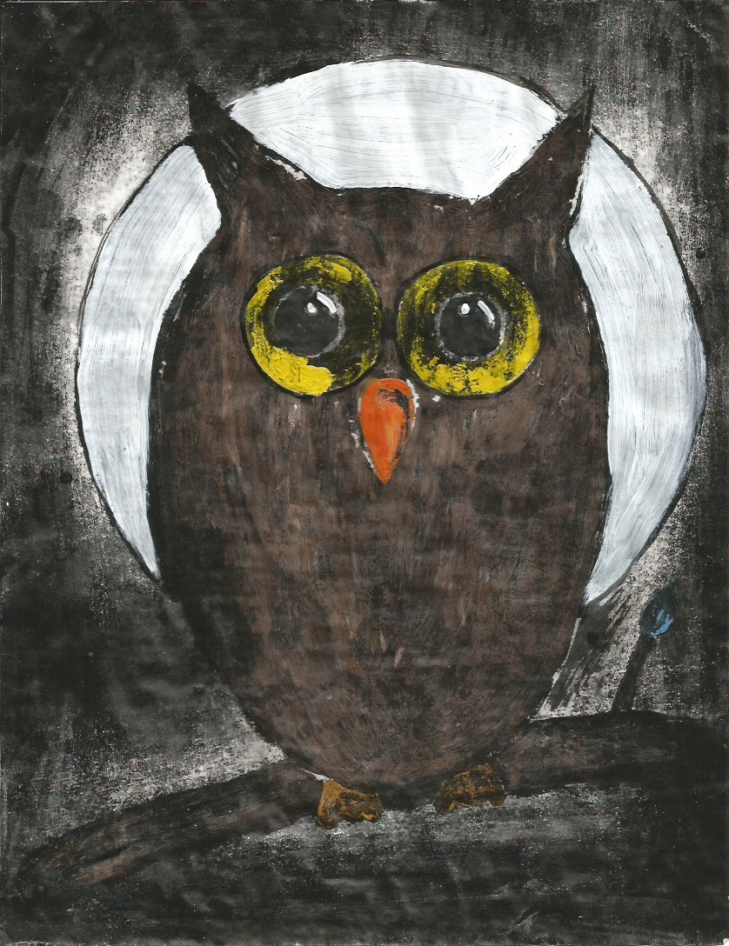
Ink resist technique:
This unique art technique came to me when I was in high school, way, way, way back in the 80’s and it has been one of my favorite art techniques for its complexity, yet it has a completely different look. The project results look nothing like any other technique you may learn in any art course you ever take in the future.

When it comes to creating your initial drawing and then applying the gouache or tempera paint on the surface, you have to think in reverse, almost like looking at a negative of a photograph.

Gouache or tempera paint, is used as a resist to the ink in this lesson but there are many other media that can be used such as wax crayons, watercolor paint, acrylic paint, oil pastels, Vaseline (petroleum jelly) and even liquid dish soap!

My 14 year old daughter Abbey created an owl on a branch for her India Ink Resist / Floatation Art piece. She named it Midnight HOOT!
Gouache Paint:
Gouache, pronounced (ɡwäSH,) is an opaque watercolor, and is a type of watermedia, paint consisting of natural pigment, water, a binding agent, usually gum arabic or dextrin, and sometimes an additional inert material. Gouache is designed to be used with opaque methods of painting. The term, derived from the Italian guazzo, also refers to paintings using this opaque method. Gouache has a considerable history going back over 600 years. It is similar to watercolor in that it can be re-wetted, it dries to a matte finish, and the paint can become infused with its paper support. It is similar to acrylic or oil paints in that it is normally used in an opaque painting style and it can form a superficial layer. Many manufacturers of watercolor paints also produce gouache and the two can easily be mixed together.

Student Assessment / Participation:
The students’ art pieces will be assessed not by the quality of the finished image; (this idea is subjective in nature and grading such, would be unfair based on varying skill levels of all students in a given class; assessment would be extremely difficult.) grading should be assessed more by the accomplishing of the steps in proper order. Missing any steps, or steps out of order would make the image impossible to see as a result. I included a vocabulary list that you can go over formally or informally as you see fit. I gave my student the quiz and watched her squirm a bit. She has been in art classes in her Arts Charter school since the 3rd grade and as she’s going into 9th grade this year, she knows a lot of the list, but some words were tricky for her. This tells me that it’s a challenging enough list to implement a quiz for this grade level.
Variations:
The variations of this lesson are more based on materials (i.e. cardstock or watercolor paper or canvas – gouache or tempera paint or acrylic paint) and not the overall execution of the steps. The process should be as-it-reads, in the step by step guide of this lesson. Teachers, you should practice this technique on your own at first to work out any kinks before trying to implement the lesson in your class for the first time.
______________________________________________________________________________
Resources:
https://en.wikipedia.org/wiki/Gouache
www.visual-arts-cork.com/drawing/pen-and-ink-drawings.htm
https://youtu.be/Su1Uh2QCEGQ?t=149
https://youtu.be/tPK5A__BBIo?t=43
https://youtu.be/GXfB5bSpqo4?t=433
https://youtu.be/p5Rt8q43d8Q?t=105
https://paintingdemos.com/ink-resist-technique-on-canvas-crow
www.dickblick.com
This Art lessons’ Vocabulary Words

Acrylic / Archive
Black / Bleed
Board
Canvas / China
Concept / Create
Cardstock
Dark / Demonstrate
Dense / Develop
Drawing / Dry
Dye
Effect
Finish
Floatation
Gel Medium
Gesso / Gessoed
Gouache
Hair dryer
Image
India ink
Kneaded eraser
Light / Lightly
Line-work
Materials
Matte
Measure
Media / Medium
Monochrome
Obliterate
Opaque
Painterly
Picture-plane
Pigment
Polyurethane foam
Resist
Revealed
Reverse
Re-wet
Rinse / Rub
Sable-brush
Scratch / Sketch
Sponge / Supplies
Surface
Technique
Tempera
Translucent
Transparent
Unique
Wash
Watercolor
Waterproof
Wet
White

