LESSON PLAN: GROWTH MINDSET

OBJECTIVES:
Students will be able to:
- know the difference between fixed and growth mindsets,
- begin to identify their own mindset,
- recognize statements that are categorically fixed or growth mindset statements
- and make a goal for their mindset/self-talk.

Activity #1: Show Carol Dweck video + brief discussion of their immediate reactions (15 min) - Growth Mindset - animated Carol Dweck lecture

Activity #2: Whistle for Willie in Spanish - discuss message in terms of growth mindset: https://www.youtube.com/watch?v=9_JecOBES-4
  - Discuss storyline (for comprehension)
  - Ask questions about Peter’s mindset
  - Emphasize the power of “yet”

Activity #3: Two volunteers come up to read mindset statements to each other in front of the classroom. (Brief discussion about how the students sounded. Which one sounded like you?) Change the message if it is a fixed mindset statement to a growth mindset statement.
  - 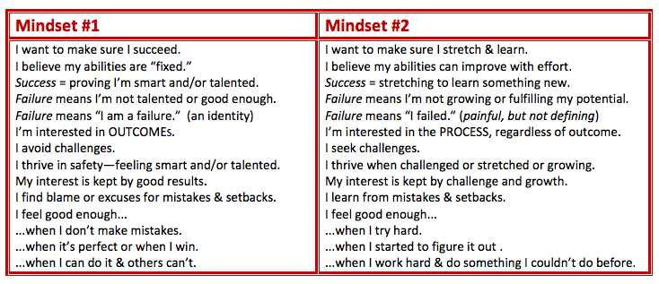

Activity #4: Show and discuss the mindsets in “Soar”: http://www.teachingideas.co.uk/video/Soar
  - Stop movie from time to time to discuss/think of some thought bubbles for the characters. Do these reflect mindset?
  - What might have happened without growth mindset? What happened thanks to growth mindset?

Activity #5: Categorizing fixed mindset and growth mindset statements: Kahoot
Growth Mindset or Fixed Mindset statements Quiz

Closure: (Take out a piece of paper for reflection. Name on it. You will turn it in.)
- It’s time to make one goal for yourself with today’s lesson in mind. Will you make a goal to change your self-talk? Will you make a goal to support a friend with a strong fixed mindset? Will you continue with your growth mindset, but be aware of trouble spots when it comes time for (potential rejection) auditions, applications, breakups, etc.? Will you change your mindset in a specific subject area or class by adding the word “yet” when you start getting frustrated… etc.
- Lastly, Please write any feedback for me to know what you liked/didn’t like about this lesson. Are there any observations that you didn’t share with the class yet that you would like to share with me now?

