Lesson Plan The Mitten PreK-K

Unit/Topic: Letter m, winter Book: The Mitten by Jan Brett

Objectives:
- Learn the letter m.
- Identify letter m by sight.
- Say the sound m makes.
- Name other words that start with m.
- Predict and sequence the next parts in a story based on context clues and illustrations.
- Retell a story

Lesson:
- Introduce the letter m at circle time. Show the class the letter and use the prompt, “m, Mickey Mouse, mmmmm.” Repeat this while clapping until students seem to have it.
- Model how to write an m. Have children hold up their finger in the air and ‘write’ the letter in the air.
- Point out the letter M on the cover of The Mitten. Explain that mitten is a word that starts with m. Have children say mitten and ask if they know other words that start with m. List these on the board.
- Read the story, explaining that there is a hint of the animal that will come next in the border of each illustration. Have them use this to predict what will be on the next page.
- When finished, discuss the last page, helping them draw inferences about why Baba looks confused when looking at the two different sizes of mitten.
- Small Group Activities:
- art: drop piles of a few colors of paint onto a mitten made from construction paper. Place another mitten on top of it and have children rub them together (without sliding them). Peel them apart and you have ‘matching mittens’.
- Mitten letter hunt: Use a dot stamper to find ONLY the m’s on the mitten. (We also were working on letter d so the children had to stamp both letters).
- Practice writing letter m on handwriting paper.
- Retold the story using laminated ‘props’ for characters. Hold the book for students to see and talk through it, asking them what happened first, next, etc. Emphasize using the illustrations to predict what is coming next. Use the props to emphasize the sequence of the story. 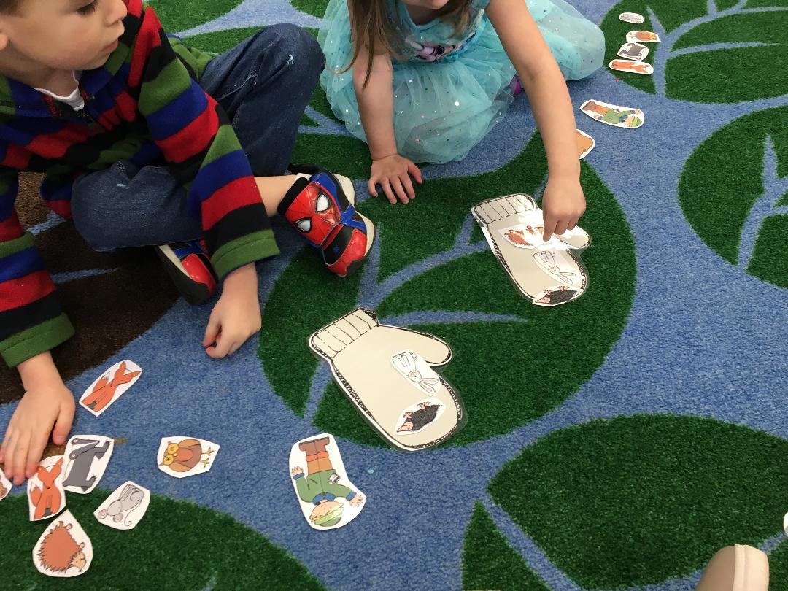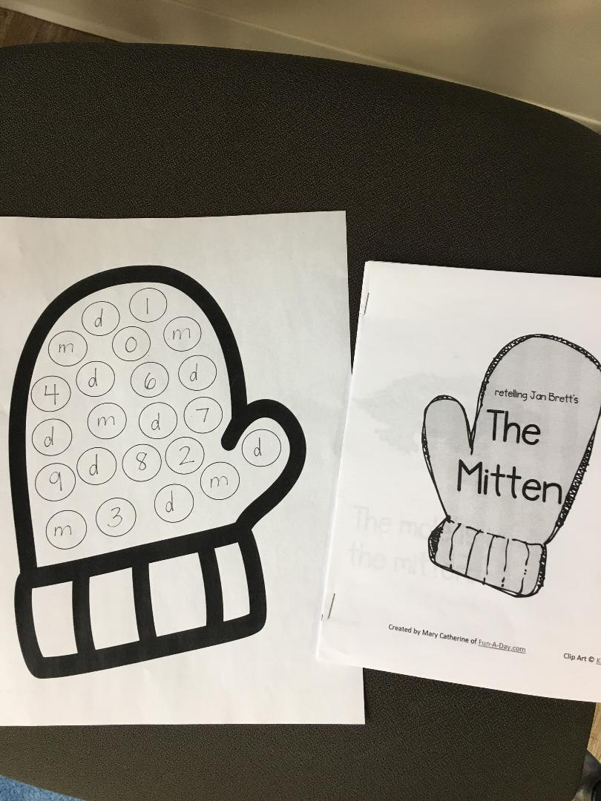
- Large Group Activities:
- Model how to retell the story using props.
- Used rhyming pairs that are on drawings of mittens to make matching mitten rhymes. Each student had a card and as a class had to decide which one it rhymed with. (Can do this in small groups as well.)
- Read and review the m word list previously made and add any new words.
- Using a printable emergent reader, read it together, again emphasizing the sequence of the story.

Assessment
- Identify the letter m in isolation.
- Retell the story independently (using props).

