Aleta Doss
Mathematical Mindset: Assignment #9
January 2018
Choosing the Right Function
Traditionally, I would give students a lengthy handout to practice graphing different functions and finding the intersections point of any system of functions. The task is difficult, as many different types of functions are included, such as linear, circle, quadratic, piecewise, square root, cubic root, step, absolute value, constant horizontal, and constant vertical functions. Finding solutions to systems with non-linear functions is challenging and some systems do not have solutions, some cannot be solved algebraically, or the solution cannot be found using the algebraic techniques we know. For example, algebraically combining: y = ln x and y = (x^5-4x+7)^(3/4) is not an option for my students. Students were overwhelmed with the cumulative nature of the task and felt defeated while trying to solve the problems. Sadly, some students respond to more complex tasks simply by skipping them, and hoping that they will not need to apply the information another time.
Instead, I designed a project that incorporates finding solutions both graphically and algebraically. Graphing adds a visual component. I ask students to complete the graphs using Desmos because they need to be comfortable with this tool for their state test. Most students have the Desmos app downloaded on their phone, and I also have one Ipad available. The free tool is easy to use and graphs functions which are not solved for “y.” Graphing calculators are limited to functions expresses as y = … and some functions such as circles are often expressed in the form (x-a)^2+(y-b)^2 = r^2.
Also, students can choose which equations to pair and solve. Choice is powerful as it adds interest to what could otherwise be a dull learning task. The choice element also opens the task allowing students to complete it in many different ways. An element of strategy is involved as students need to solve at least four of their pairs of functions with algebra. They must carefully choose where and how to use the “easier” functions, such as a constant horizontal function, in order to create pairs that can be solved algebraically. The task becomes a fun puzzle.
When I passed out the work, I was surprised by the response of my students. I would have thought it common place to find my advanced students complaining about the difficulty involved in the graphing project. They did not. Instead, students took the challenge and turned in EXCELLENT work. Projects were neat, complete, and reflected dedicated time spent learning. Many did not choose simple equations, but signed themselves up for the extra work of harder functions. For students it was an excellent low-floor, high ceiling task. Every student had the skills to begin solving especially using their calculator as a tool to aid their thinking. No one commented on the natural complexity of combining a whole semester’s worth of functions. Instead, the students seemed to enjoy the opportunity to reason through the solutions. They focused for long periods of time, working out the relationships between complex functions. I was amazed at how open-ended questions led my students to think more deeply. I believe that my students learned more through completing this task, and they enjoyed it!

THE HERITAGE INSTITUTE
ONLINE COURSE
LESSON PLAN TEMPLATE
Grade Level: ___9-12___
Subject: ___Mathematics – Algebra II___
Theme/Topic: ___Graphing – Algebra II___
Student Outcomes:

The following standards will be applied as students will be finding the intersections of functions both algebraically and graphically.

Analyze functions using different representations.
CCSS.MATH.CONTENT.HSF.IF.C.7
Graph functions expressed symbolically and show key features of the graph, by hand in simple cases and using technology for more complicated cases.*

Solve systems of equations.
CCSS.MATH.CONTENT.HSA.REI.C.5
Prove that, given a system of two equations in two variables, replacing one equation by the sum of that equation and a multiple of the other produces a system with the same solutions.
Required Materials and Equipment:
Desmos on student phones or my Ipad, handout, pencils, notebook paper
Agenda:
Students will spend at least most of a period beginning the project and then we will discuss a reasonable due date at least a week in the future. (I have found that determining due dates for major projects with the class to be very effective at decreasing anxiety and increasing the number of on-time projects.
Warm Up and Anticipatory Set (12 minutes):
I will have the students select any two equations from the following list:
Linear, circle, quadratic, piecewise, square root, cubic root, step function, absolute value, constant horizontal function, constant vertical function
Students will be challenged to create a system with the most solutions. Creative and interesting systems will be shown to the class and will serve to help students understand the project.
Direct Instruction (10-15 mins):
With a neighbor I will have students create a system of a parabola and a circle. Student teams will be asked to solve the systems both graphically and algebraically.
Next, we will discuss the project as a class.
Guided Practice & Independent Practice (20 mins or more):
A minimum of twenty minutes of class time should be spent in class so that all students can start working, and have all their questions answered before they leave to complete the project at home.

Project – A CCSS Review of Graphing
Select two of the functions listed below and find their intersections graphically and, if possible, algebraically. You must solve at least 4 of the systems algebraically. Use www.desmos.com to graph each.
Linear, circle, quadratic, piecewise, square root, cubic root, step function, absolute value, constant horizontal function, constant vertical function
Closure (7 mins):
First, I will ask students to share with a neighbor the strategies that helped them complete the tasks of this projects. Then, I will select students to share what strategies they discussed with their neighbor. After the classroom conversation students will have more ideas of how to complete their project.
Assessment and Follow-Up:
Scoring Guide:
- All equations are correctly included.
1 2 3 4 5 6
- Algebraic solutions are accurate.
1 2 3 4 5 6
- Graphic solutions are accurate and completed with the Desmos calculator.
1 2 3 4 5 6
- Work is neatly presented and readable.
1 2 3 4 5 6
Student answers may vary. The following are examples.
- 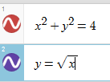 solutions: (1.56,2.43) (-2.56,6.56)

- 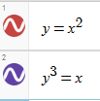y= x², y=the cubic root of x solution: (0,0)

Note the tricky way to graph a cubic root on Desmos.
- 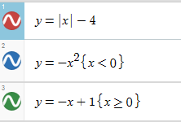
solutions: (1.56,-2.44) (2.5,-1.5)
- Greatest integer function x, x=1 solution: (1,1)
- y=x+5, y=3 solution: (-2,3)
Examples of answers with graphing
1) 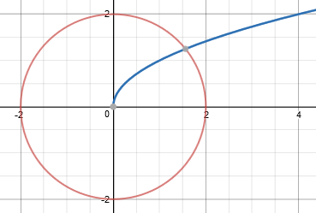
2) 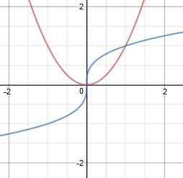(y³=x)
3) 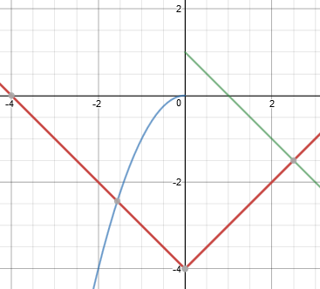
4) https://www.desmos.com/calculator/zxqltmiej3
(The above site is a good example of a floor step function.)
5) 