Name: Jennifer Culler Instructor Name: MaryAnn Johnson M. ED ADM
Course Number: ED446H, ED546H Course Name: Organizing From The Inside Out
Date: April 30, 2018 Level: Credit 500
Assignment # 9-A

Organizing #9-A
First Grade Science Lesson-Clouds
Objectives: -Students observe and discuss clouds. -Students create their own classification schemes for sorting cloud photographs. -Students sort the cloud photographs using the categories stratus, cumulus, and cirrus. -Students make three dimensional pictures to record their observations of clouds.
(3.1.4.C.1., 3.2.4.B.1., 3.2.4.B.2., 3.4.4.A.1., 3.5.4.C.1., 3.6.4.B.4.)
Materials: chart paper, marker, book It Looked Like Spilled Milk By, Charles G. Shaw, cloud classifications picture, sets of 9 cloud photographs, 3 sets of index cards with cloud names on them, light blue construction paper, pencils, cotton balls, glue.
Procedure:
1-How many of you like to look at the clouds in the sky? Why?
Kids responses: They are pretty. They are funny. It is fun to look for shapes and animals in them.
2-We are going to listen to a story about what clouds might look like if you use your imagination.
Read or listen to the story It Looked Like Spilled Milk By, Charles G. Shaw
For the last couple of weeks, we have observed the clouds. You have helped me to record the cloud coverage on the weather calendar using the words sunny, partly cloudy, cloudy, and foggy. Today we are going to dig in deeper and talk more about the different cloud types.

3-Make a cloud web cart-what does the word cloud make you think of?
Kids responses: white, big, fluffy, pretty, fog, bring us rain, make snow, make different shapes
4-Clouds are a collections of water droplets. The amount of water that they contain varies greatly, but, in general puffy clouds contain more water than wispy – thin ones.
We are going to talk about 3 different types of clouds:
Put up cloud classifications picture on the smart board.
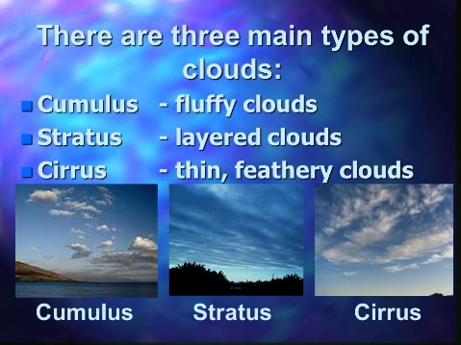
Stratus Clouds form closest to the earth, they are gray, and fog is a stratus cloud
Cumulus clouds are higher than stratus clouds. They can look like huge cotton balls. They are usually associated with fair or good weather, but they can develop into thunderclouds.
Cirrus clouds are the highest clouds. They are made up of tiny ice crystals. They are wispy looking and are sometimes referred to as “mare’s tails.”
5-Sing song-to the tune of If You are Happy and You Know It
If you are Stratus and you know it you are way down low- (have the kids reach the floor)
If you are Cumulus and you know it you are in the middle- (have the kids wave their hands around their bellies)
If you are Cirrus and you know it you are way up high- (have the kids wave their hands above their heads)
Kids responses: All kids participated and enjoyed singing and moving to the song. We sang it 2 times.
6-Put kids into groups with cloud pictures. Tell them they are challenged to sort the photos into three groups. Put all the Stratus clouds together, cumulus together, and Cirrus together.
(Have groups set up. And three index cards with cloud names.)
Kids responses: Several of the kids had trouble distinguishing between cirrus and stratus clouds. I stopped at each group and helped them compare the pictures to the cloud classification picture on the smart board.
Review the answers. And discuss.
Kids responses: only 1 group had mixed up cards. The rest had them correct. The kids explained that they looked at the clouds to see if they were “big and fat” then they knew they were cumulus or “in the middle.” They also said if the clouds were “thin” they knew they were cirrus and “way up high.” The clouds that were stratus were “way down low like fog.”
7-Take to kids out side to look and observe the clouds. Have them pick a cloud to make with cotton balls.
Kids responses: we were lucky and it was a good cloud day! The kids were saying they saw “rabbits, dinosaurs, ducks, cars….” They loved looking at the clouds.
(if it is bad weather or there are no clouds. Put cloud picks on the smart board.)
8-Have them write under the picture about their cloud.
Kids responses: most kids chose to make cumulus clouds into a shape they saw.

Pictures incase bad weather:
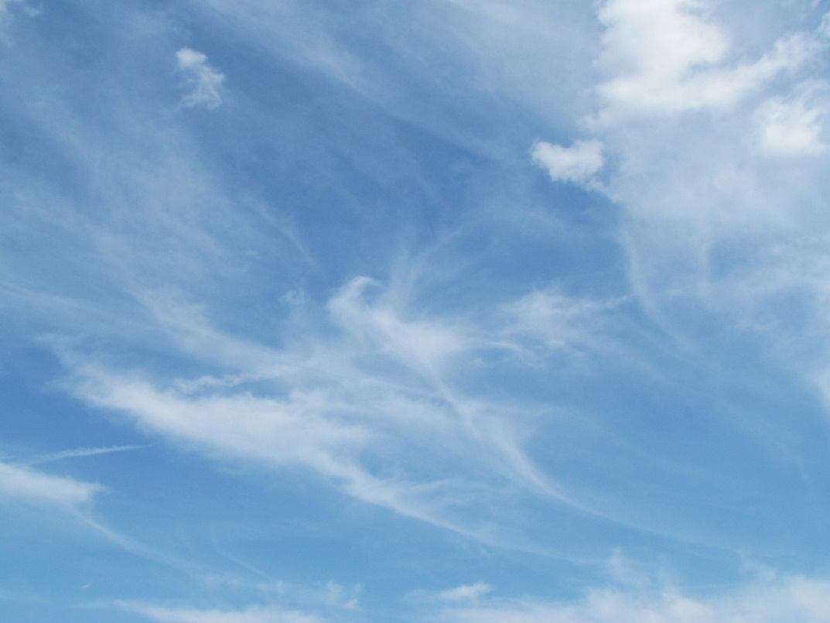
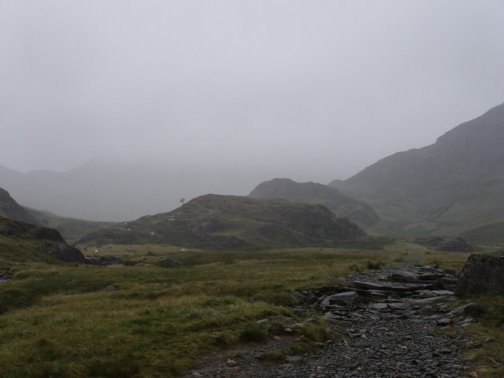

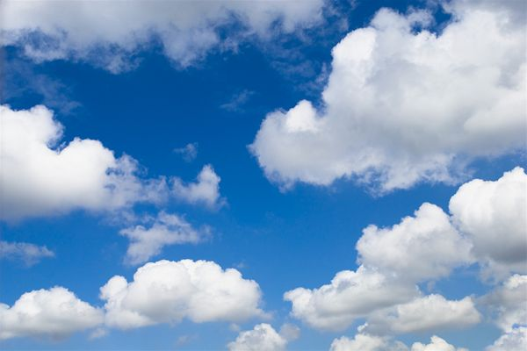
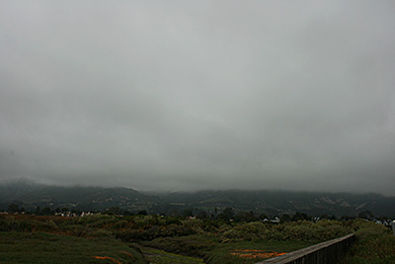

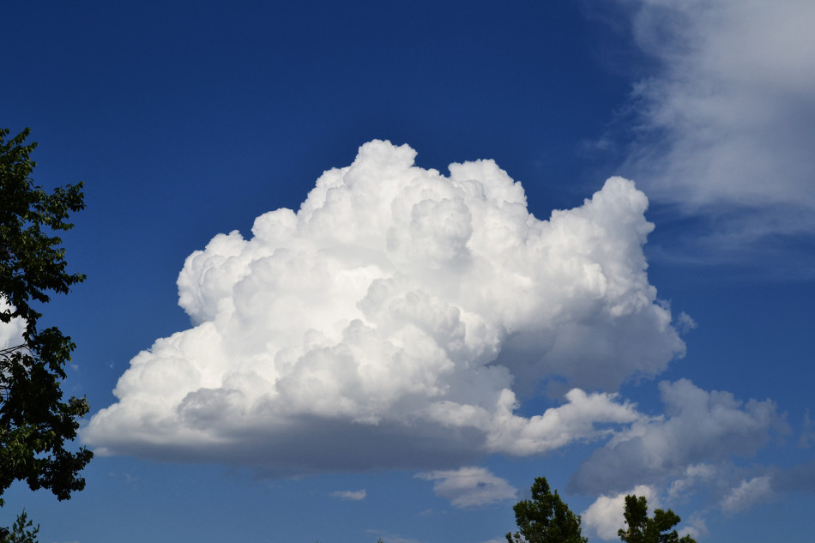
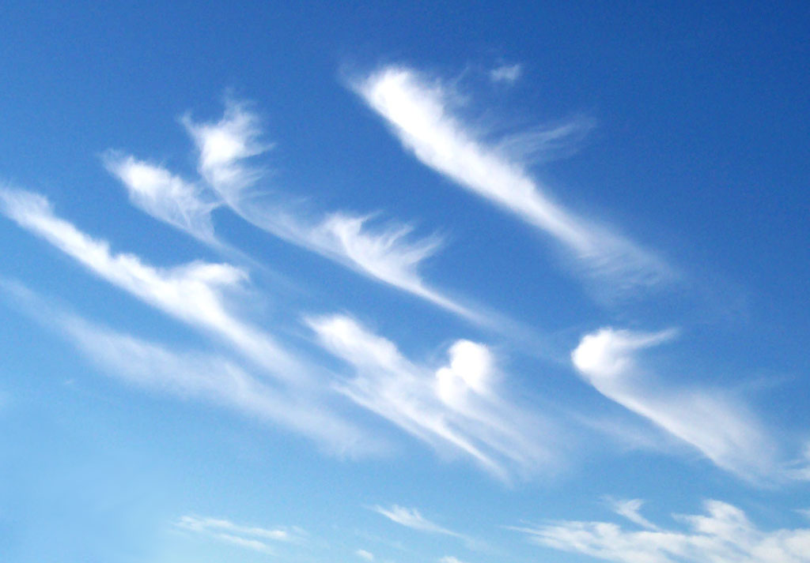

**I give the Heritage Institute permission to publish this lesson plan in The Heritage
Institute Lesson Plan Library, a feature available only to active learners taking THI
courses.

Commentary:
This was a fun lesson for the kids. First graders become so excited the minute I say we are doing science today! This course has taught me to make sure I start with a plan. I knew I had to teach the lesson in an hour and a half, so I had to keep a good pace going with the lesson. I made sure I had a list of all the supplies I would need for each of the eight steps in the lesson. I also made sure to think ahead and had a plan in case there was bad weather and we could not go outside. Having my supplies set up in zones around the room so they were ready when I needed them helped with smooth transitioning during the lesson. I had steps 1-3 set up at the carpet. My book, chart paper, and marker were all by my chair. For step 4 the kids all came back to their seats and the pictures were already set up on the smart board. Step 5 was done with the kids standing by their desks. Step 6 was set up on three of the center tables ahead of time and labeled with the kid’s names that should go there. Step 7 was walking outside. Then when we came in I had all the materials for step 8 laid out on the back table. Deciding to make a plan to make sure I was organized before I started the lesson, along with sorting my supplies and placing them in planned out zones helped my lesson flow smoothly. Next time, I do need to use less cards in the cloud classification activity. This would make it a little bit simpler for the kids.

