Domain: Number and Operations-Fractions
Standards:
- 4.N.NF.3 Understand fraction a/b with a>1 as a sum of fractions 1/b
- 4.N.NF.3b Decompose a fraction into a sum of fractions with the same denominator in more than one way, recording each decomposition by an equation.
- 4.N.NF.3a
Materials: Paper, pencil, pattern blocks
Task: There is a plot of land shaped like the figure below. Each hexagon has a value of 1 whole unit. The plot of land, therefore has a value of 3 whole units.
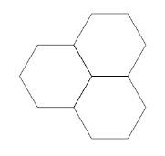
Determine how to use pattern blocks to divide the shape up into the following ways. For each way, make a picture and write an equation.

Part 1: The land owner will only sell the land in sections that are one-third of a unit. The lowing people buy land:
- Taylor: 2 sections
- Bill: 1 section
- Nick: 4 sections
Use your pattern blocks to make a picture of how the land was divided up.Is there any land left? If so, how much?
Write an equation to show how the land was split up by the land owner.

Part 2: The land owner will only sell the land in sections that are one-sixth of a unit. The following people buy land:
- Tom: 3 sections
- Susan: 2 sections
- Bob: 4 sections
- Mallory: 1 section
- Wes: 6 sections
Use your pattern blocks to make a picture of how the land was divided up. Is there any land left? If so, how much?
Write an equation to show how the land was split up by the land owner.
Level I | Level II | Level III
Limited Performance  - The student has not shown a clear understanding about how to represent the pieces of land as a fraction. | Not Yet Proficient  - Answer is correct, but the equation or explanation is incorrect OR work is logically shown but the student has made a calculation error. | Proficient in Performance  - Solutions: Part 1: There are 2 sections left or 2/3 of a unit left. 2/3 + 1/3 + 4/3 + 2/3= 3.  - Part 2: There are 2 sections left or 2/6 of a unit. 3/6 + 2/6 + 4/6 + 1/6 + 6/6 + 2/6.

Standards for Mathematical Practice:
- Makes sense and perseveres in solving problems.
- Reasons abstractly and quantitatively.
- Models with mathematics.
- Attends to precision.

Name______________________
There is a plot of land shaped like the figure below. Each hexagon has a value of 1 whole unit. The plot of land, therefore has a value of 3 whole units.
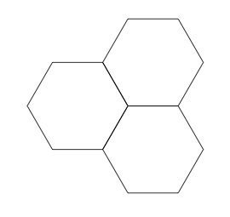
Determine how to use pattern blocks to divide the shape up into the following ways. For each way, make a picture and write an equation.

Part 1: The land owner will only sell the land in sections that are one-third of a unit. The lowing people buy land:
- Taylor: 2 sections
- Bill: 1 section
- Nick: 4 sections
Use your pattern blocks to make a picture of how the land was divided up. Is there any land left? If so, how much?

Write an equation to show how the land was split up by the land owner.
Part 2: The land owner will only sell the land in sections that are one-sixth of a unit. The following people buy land:
- Tom: 3 sections
- Susan: 2 sections
- Bob: 4 sections
- Mallory: 1 section
- Wes: 6 sections

Use your pattern blocks to make a picture of how the land was divided up. Is there any land left? If so, how much?

Write an equation to show how the land was split up by the land owner.

