Christa Pruss Assignment #9 Webstorm Lesson Plan
Essential Question
Can I explain the organization of Mayan Civilization (roles, structures, ceremonies)?
Can I compare and contrast the Mayan Civilization to modern through social, political, cultural and economic developments?
Learning Standard
Historical Knowledge 6.1:Determine and explain the historical context of key people, cultures, products, events, and ideas over time including the examination of different perspectives from people involved including, but not limited to, Aztec, Maya, Inca, Inuit, early Native American cultures of North America, major explorers, colonizers of countries in the Western Hemisphere, and the Columbian Exchange.
Learning Goals
Students will be able to categorize nodes efficiently to show understanding of the Mayan civilization after reading text, Mayan market simulation and Socratic seminar discussions.
Materials and Accommodations
Text Books
INB’s
Sticky Notes
Day 1
Pre-assessment as a group. Discuss and look at the sticky notes on the butcher paper. How could we categorize them? What do you know about the Mayans? What seems similar and different to our civilization?
Begin reading Mayan chapter in small groups while using AVID reading comprehension note taking strategies (summarize, connect, visualize, respond, clarify, question). Students will read with their table groups or in a small group with me for those that need a bit more scaffolding with reading comprehension and notes or with the EL teacher to support language needs.
Day 2
Continue reading Mayan chapter while also beginning our Mayan market simulation. Students are in table groups as lowland, highland, peasant or coastal traders. They each have specific goods and they work in teams to trade items that will allow them the best chance of survival based on where they live knowing that the market is only open every 5 days (we use minutes of time to represent the 5 days between markets). There are different scenarios that occur after each trading session that either benefit or hinder their goods collected.

Day 3 and 4
Market and reading continue. Respond to Costa’s levels 1, 2 and 3 questions. Socratic seminar to address essential questions and responses to Costa’s questions.
Day 5
Complete the webstorm independently to show understanding of the Mayan Civilization.

Reflection
Webstorming was a powerful way to introduce Mayan Civilization to my students. I began class with sticky notes spread all around a large piece of butcher paper. I asked them what they thought….what do they know or think they know about Mayan culture. How could we organize or group the sticky notes? Right away hands went up and they all had thoughts. When there were disagreements they discussed until we came up with a placement on the web for now. As the week went on we read each section in their text book on the Mayans while using the summarizing strategy from AVID. Several students started to make connections to the web we had created. After reading through the chapter in small groups students had a Socratic seminar sharing their interests, wonderings and responses to their Costa’s questions. Student then made their own revisions to the original web adding subtopics and regrouping in their interactive notebooks. We came back together as a whole group and students shared their changes until we collectively agreed upon the revisions and subtopics added to our original class web. I was able to view all of their independent work and their understanding of the Mayan Civilization.
Webstorming was engaging and interactive as well as freeing for me as a teacher. I was able to introduce a new topic with high interest. It was a quick pre-assessment for me to understand what they already know and what they are interested in within the topic. I also noticed that they found more opportunities to wonder and notice while reading the text and looking at our original web. I love those moments when students are empowered and show a true love of learning. Each day ended with students discussing the web and making connections to the reading. At the end of the week students were excited to create their own version in their notebook. I felt was able to quickly assess each students understanding without occupying extra time. We concluded as a whole group comparing and contrasting their versions until agreeing upon our final class web. I enjoyed listening to their reasoning with one another and was able to hear their understanding.
Step 1
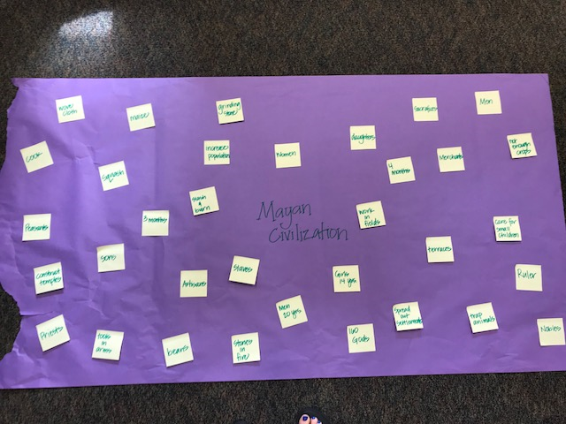

Step 2
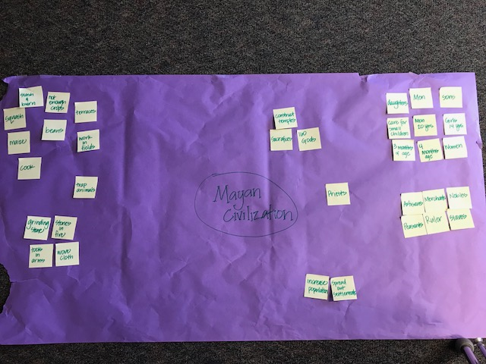

Step 3 (Independent think time)
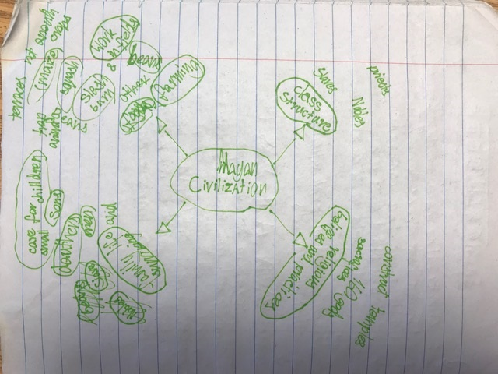
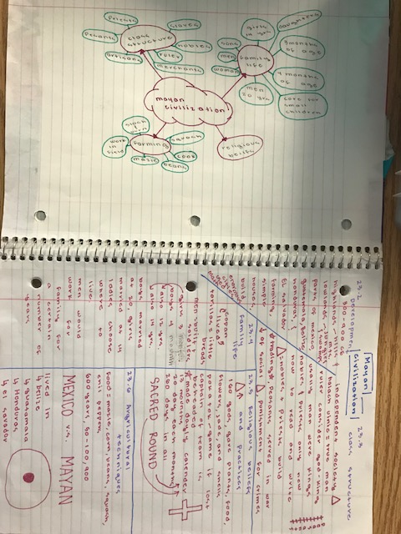

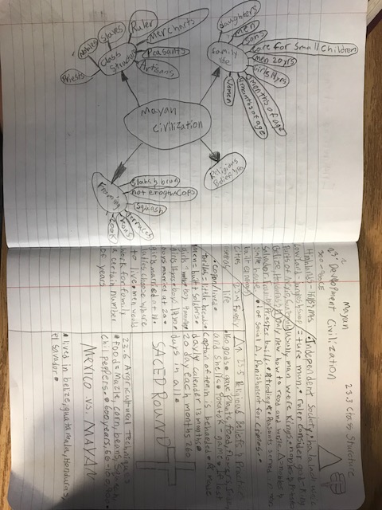

Collaboration and Discussion

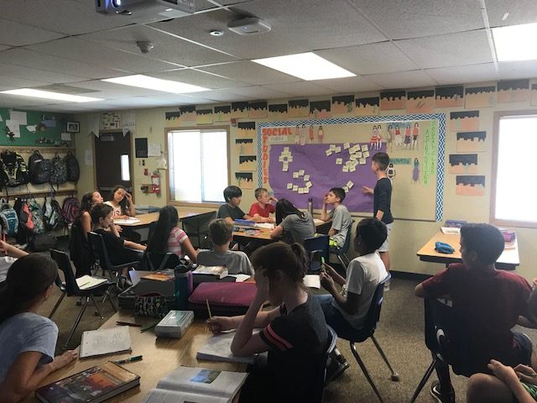

Final Consensus
