Inzie Browning
Course: Differentiation: It’s Not As Hard As You Think
Assignment #10: Lesson Development

Lesson: Counting and Writing to 120
Subject: Math
Standard: 1.NBT.1
Objective: Students will be able to count and write their numbers to 120.
Time: 60 minutes
Materials: Place Value Chart, base 10 blocks, pencils, Place Value Worksheet with vertical boxes, What’s Missing worksheet, Ordering number cards, Place Value Puzzles, and Count By Puzzles.
Lesson Introduction: Warm Up-5 minutes
Students have been practicing counting from 1 to 120 since the beginning of the school year. Have the students clap their hands, slap their knees, or snap their fingers as you count from 1-120. Then have the students do it counting by 5’s and 10’s. This gets them moving and thinking about numbers.
Whole Group Instruction-25 minutes
Start by flipping through the cards on the place value chart. Ask the students to tell you how many numbers are on each card (only 1). Explain to the students that there is only one number on each card because when we reach the number ten, we have a set that can be bumped and moved over to the next place value. Demonstrate with the ones place first. Show the students that we can only go to the number 9 because we can’t write the number ten on it because it can only hold one numeral. Bundle the set of tens together using the base 10 blocks. Ask the students to tell you how many sets of ten and ones you have (one set of ten and zero ones). Tell the students you are going to keep adding more sets of ten (keep dropping tens until you have 9 bundles of tens). Show the numbers on the place value chart as well as you go. Ask the students to tell you what number you have made (90). Drop one more bundle of ten and tell them you now have 100. Ask them if you are supposed to put all 10 in the tens place (no, because we have a one hundred place to use). Bundle the 10 sets of 10 together and put them in the hundreds place. Explain to the students that you have 1 one-hundred, o tens, and o ones.
Now that the students know this begin showing them how to make the numbers 101, 102, etc. Pass out the vertical place value paper to the students. As you make each number, display the place value worksheet with the vertical boxes on your smartboard or chart holder (depending on your classroom resources). Write the numbers on the sheet as you make them using the base 10 blocks and displaying them on the place value chart. Make sure the students see you writing one digit in each of the boxes for the numbers. Have the students copy the numbers on their paper as you are writing them on yours. Point out that each digit has its own box. This will help stop the students from making the mistake of writing 100 and then putting the next digit beside it (example:1001 for 101).
Independent Practice: 10 minutes
Students will continue to use the same worksheet that was worked on as a whole group. Ask them to start with the number 101 and write their numbers to 120 using the horizontal table at the bottom of the page. Explain to the students for these boxes they will write all 3 digits for the number in the same box. When the students have finished check their progress.
Lesson Extension/Closure: 20 minutes
Pass out the What’s Missing worksheet and have the students write in the missing number on the 120 chart. Since this activity focuses on larger numbers this will help students put it into perspective with the number chart and help you to see if the students made the connection. If the students finish the worksheet before time is up allow them to choose from one of the following anchor activities:

Activity 1: Ordering Numbers Cards
Students take the numbered note cards and put them in order. Numbers range from 1-120. For students who are more advanced they may choose to do numbered cards from 120-500+.
Activity 2: Number Chart Puzzles
Students take the cut up 120 chart and put it back together. For students who may struggle, they can take the puzzles pieces and match them over an existing 120 chart.
Activity 3: Number Puzzles
Students put the puzzle pieces together by counting by 1’s, 2’s, 5’s, and 10’s. The puzzles range in difficulty from numbers 1-20 clear up to the 700’s.

Name:_________________________________________________
Write The Numbers With Me.
Write The Numbers On your Own.

Activity 1: Ordering Numbers Cards

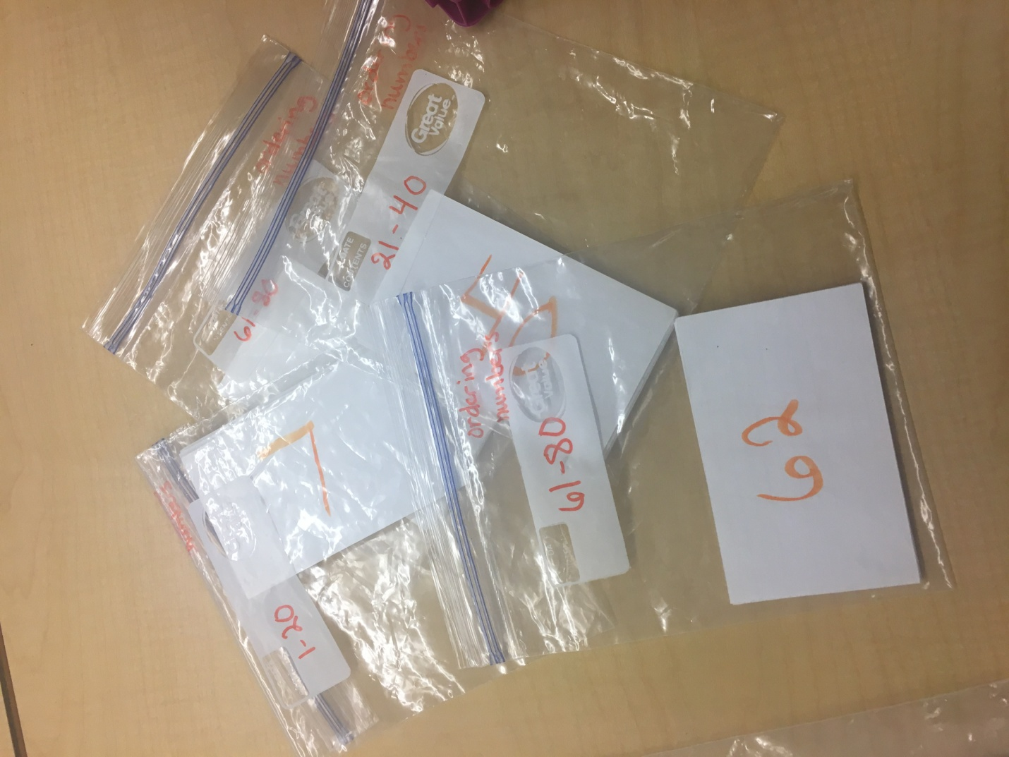

Activity 2: Number Chart Puzzles

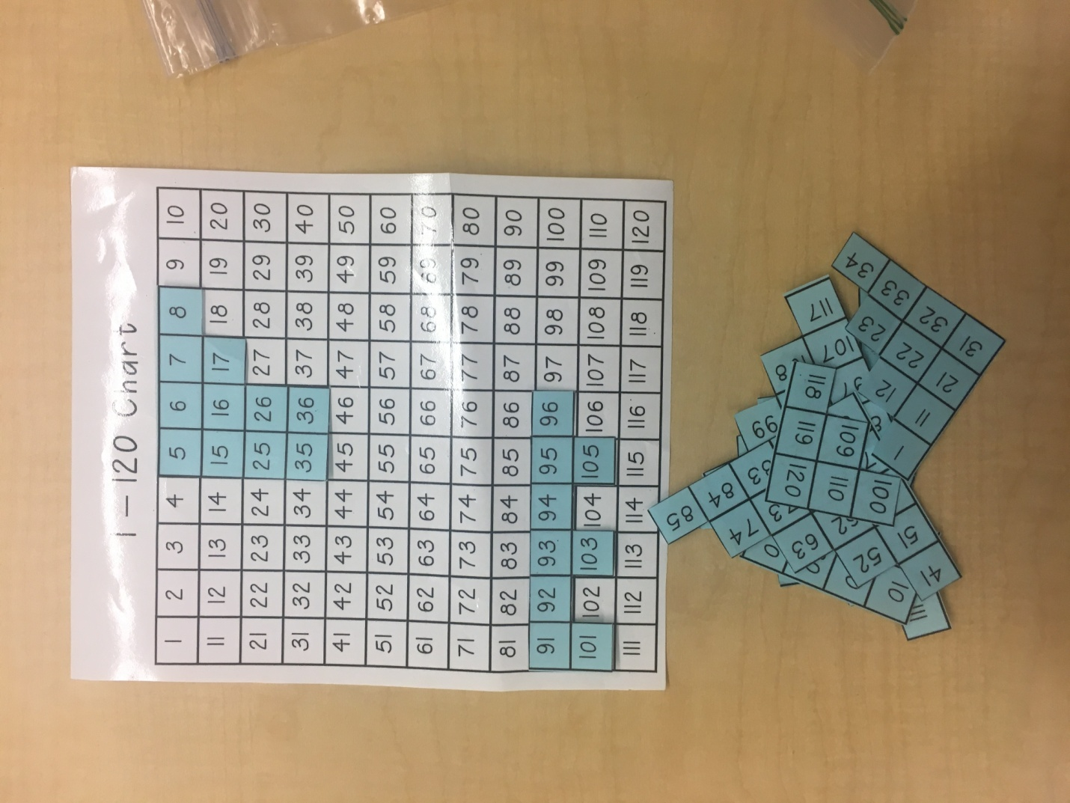

Activity 3: Number Puzzles

