Lesson Plan Design
Lesson Plan Title, and your name: Plan a Family Vacation Erica
Audience Enter grade level (& special student group if applicable): 5th grade
Enter time duration of the entire lesson: 400 minutes
Big Idea(s)/Essential Question(s): How much does it cost to book flights, hotel, rental cars, and tourist attractions? How can you modify your choices to fit your budget?
Enter learning goal(s) in the form of a question(s): What role does a budget play when planning a vacation?
Objectives(s) Enter Your Objective(s) and correlation to district standards (state, Common Core, other):
Technology Standard 7: Analyze, synthesize and ethically use information to develop a solution, make informed decisions and report results. (1.3.3)
- CCSS.Math.Content.5.NBT.B.7 Add, subtract, multiply, and divide decimals to hundredths, using concrete models or drawings and strategies based on place value, properties of operations, and/or the relationship between addition and subtraction; relate the strategy to a written method and explain the reasoning used.
- CCSS.ELA-Literacy.W.5.7 Conduct short research projects that use several sources to build knowledge through investigation of different aspects of a topic.
- Power Standard 6: Constructs and uses maps to show and analyze information

Props & Materials Enter props/materials/equipment/any learning handouts:
- Computers
- Internet
- Budget Spreadsheet
- Scratch paper
- List of websites (ie: expedia.com, Travelocity.com)
Activities/Tasks/Procedures:
Lesson 1: Introduction
- Lead a class discussion regarding vacations (what goes into planning a vacation? Where would you like to vacation? When do you need to use math when planning a vacation?)
- Whole class vacation:
  - Propose you’re going to fly from Seattle, Washington to Orlando, Florida and tickets cost $400. How much will it cost for 4 people?
  - If you’re going to Disney World, how much will it cost for everyone to go for 2 days? ($125 day/person).
  - When planning a vacation, what costs do you need to account for? (ie: flights, hotel room, rental car, tourist attractions, food)
Lesson 2-5: Destination
- Propose project: You’re planning a family vacation! You have a budget of $2,800. Your destination has been selected. You are planning a vacation for 5 total family members You need to decide on 2 tourist attractions you’ll go to, the flight you’ll take, the hotel you’ll stay at, and the rental car company you’ll use. Each meal will cost $20 per person. You will be staying at your destination for 3 nights.
- In groups of 4-5, students receive assignment of destination. Group job assignment: researchers (finds prices for expenses online) mathematician (calculates expenses on paper), recorder (records expenses on budget spreadsheet), and banker (checks all of the calculations).
- Students make a plan. What information do you need to find?
  - Tourist attractions in the area & their price.
  - Flight costs
  - Hotel costs
  - Car rental costs
- Students research and calculate the costs for their flights, tourist attractions, hotel, rental car, and food.
Lesson 6: Weather
- Explain: your trip is quickly arriving. You need to pack according to the weather. Use the 10-day forecast to plan appropriate attire for your trip.
- If your 10-day forecast has unexpected weather, you may need to adjust your tourist attractions. (ie: If you’re planning on swimming and there will be lightning, you need to change your tourist attraction).
Lesson 7: Map
- In order to make it to all of your activities, create a map of your traveling. Be sure to include one for your flight and a second map for your traveling once you’re at your destination. (have students use Google Maps to find a map of their destination)
Lesson 8: Presentation
- Create a PowerPoint including a description of the activities, spreadsheet, weather forecast, packing list & map.
Any Special Reminders:
- Differentiation:
  - Having students round to the nearest dollar
  - Using calculators
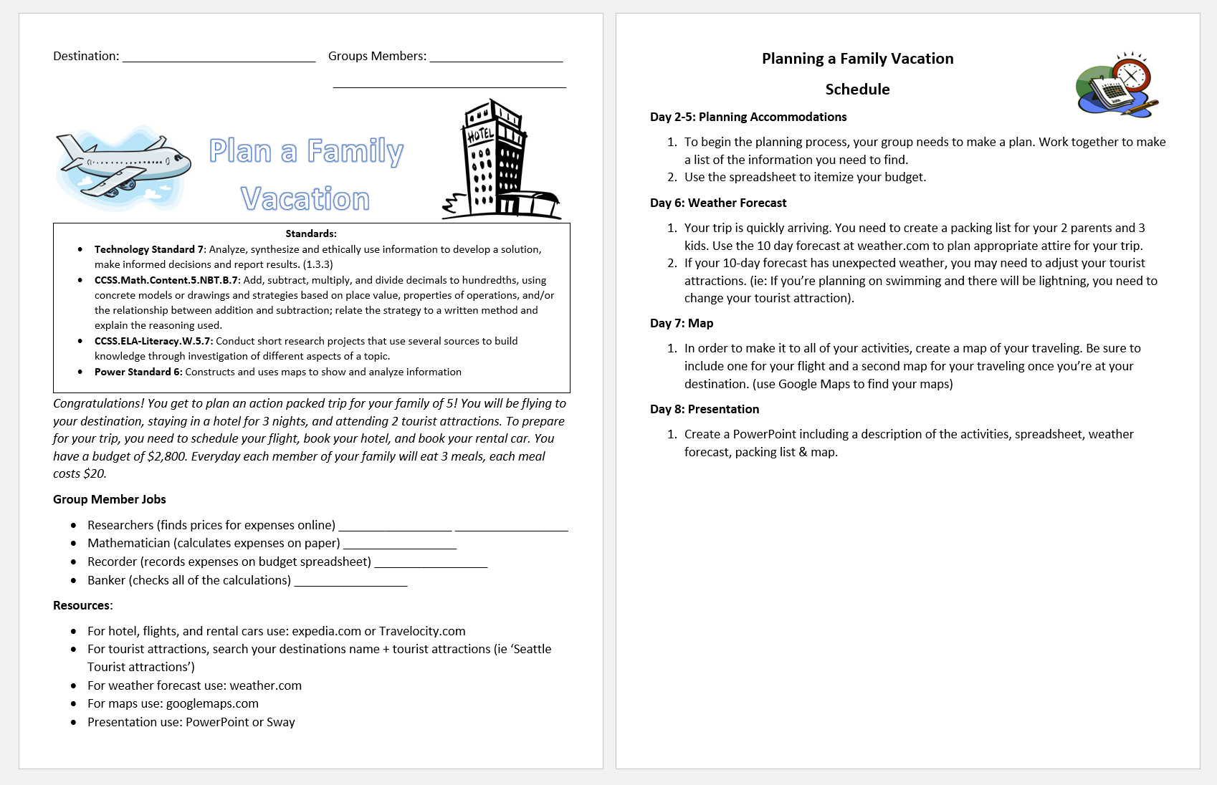
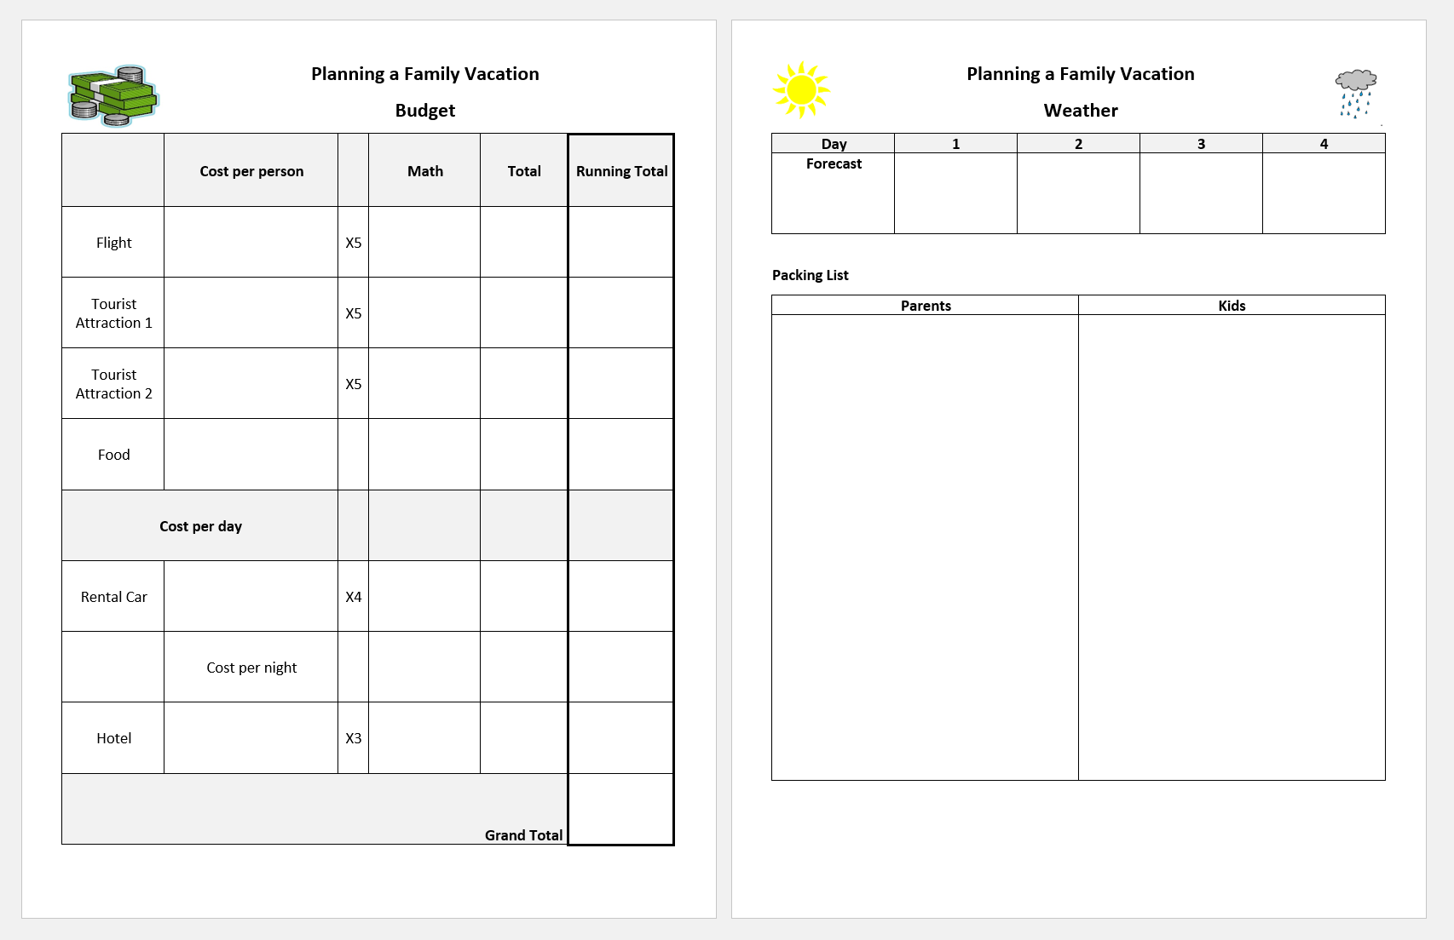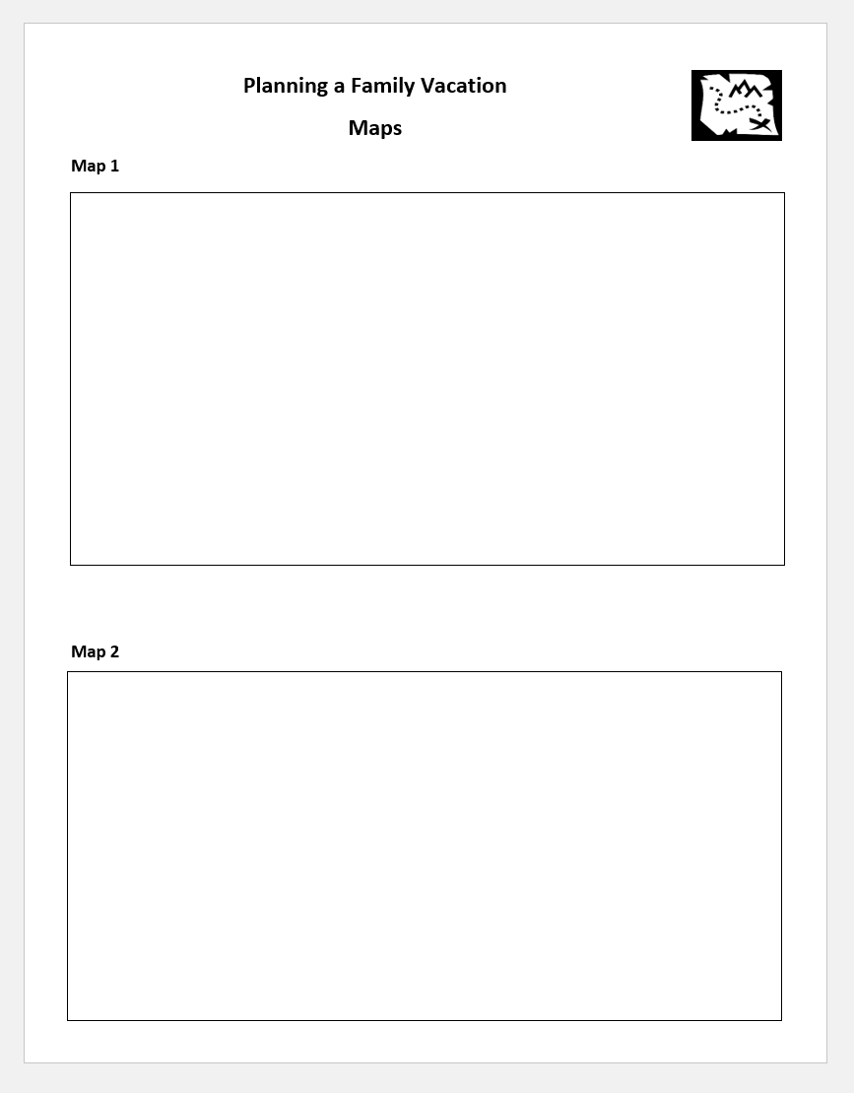

Summary:
Overall, students were excited to plan their own family vacation. They loved the idea of researching and picking their own flights and hotels. I ended up having a small group of students complete most of this project as an extension during our first math unit. The group tested out of the unit and completed the project while the rest of the class worked on the math unit. They researched and found their hotel, rental car, flight, and tourist attractions. It took some practice learning how to navigate websites and reading the search options. At first they were a little confused as to the date they should base their vacation on. They agreed to base it on the last weekend of September.
The purpose for this project was to help students calculate expenses and stay on budget. Students would use addition and multiplication of whole numbers and decimals. Students would also develop their research skills when locating prices. It allows students to connect math concepts in a real world application. For the small group, I explained the project and the group worked together to designate jobs. I gave the group quite a bit of freedom while researching and calculating their expenses. At the end of each math block I checked in with the group and reviewed their numbers. It was a little confusing to know for certain that their numbers were valid due to not seeing the website. However, this provided opportunity for students to share the calculations they made and the reasoning behind it. It was difficult to evaluate all of the members. After they finished working on the project, I had them evaluate themselves and their group. This was an opportunity for students to share if they participated and if their groupmates also participated. Since the project was more open ended, it was difficult to evaluate the budget and students progress towards the learning goals.
Next time I have students complete this project I would make some changes. Before beginning the project, I would walk students through using a website like Expedia and limit their use to only one website. Since my students are only 10 or 11 years old, they don’t have much experience browsing the internet looking for prices or navigating for good deals. It also was tricky using a website to find quotes. As students move through the project, the website may raise or lower their prices. This complicates the process because students wouldn’t be able to go back and check the prices they initially found. However, this could be solved by having students take screen shots of the prices they found.
I would also have students work in smaller groups. Although students had different roles, I found the group of 5 to have trouble staying busy. Some students had tasks to do throughout the project while others didn’t. Also, the learning goals for the project were for students to apply real world math skills, however, not all of the students were completing math based jobs.
To evaluate students better, I would print out copies of different flights, hotels, rental cars, and tourist attractions students could choose from. Although this would eliminate the research component, it would allow for me to easily check budgets and students would still be calculating expenses and maintaining a budget.
Completing this project allowed my students to apply various skills. The students who were the designated researchers got more practice navigating the websites and learning how to look for the information they need. The students who were calculating the budget had experience multiplying expenses based on the number of people, days, or nights. They also developed their skills for staying on budget. Students were able to see if they decided on a more expensive tourist attraction they would need to save money else. I think this was a good project for my students because a lot of them go on many vacations a year. This project helped them understand how costly it is to take a family vacation and may help students value the things their parents buy.
During the course of this project, I didn’t end up having students look at the weather, create a packing list, find maps or create a presentation. In a couple weeks when we’re studying maps, I may pull students back to this project to help them make connections. I could have students use the route to calculate distances in miles, yards, and feet. As another extension I could have students calculate miles per hour and determine how long it would take to travel to their hotel from the airport or tourist attraction.
Overall, this project provided me with several insights. When planning a real world math project, I need to spend more time executing the project from the students perspective. Some of the details weren’t as thought-out as they should have been. However, developing this project and seeing it in action helped me understand important pieces of projects. I need to focus specifically on the learning goals rather than the learning activities. I need to consider how long the project will take for a child to complete.

