Title: Introduction to Exponents—8th grade math
Learning Objective: Students will explore and investigate powers. Students will become aware of the power of exponents and exponential growth.
Warm up: Mountain math—done daily for math fluency.
Introduction: In order to remind students about exponents and how they work, the students will work with a partner to do the below activity. This will also help remind them that it DOES matter if the base is negative.
From Big Ideas Math Blue, Record and Practice Journal, p. 203
Activity 1: Using exponent notation.
As a class, review exponent notation at the top of p. 203. Define power, base, and exponent.
With their table partner, each student completes the table: (no caluculators)
Power Repeated Multiplication Form Value___
(-3)¹
________________________________________________________________________________________________________________________
(-3)²
________________________________________________________________________
(-3)³
________________________________________________________________________
(-3)⁴
________________________________________________________________________
(-3)⁵
________________________________________________________________________
(-3)⁶
________________________________________________________________________
(-3)⁷
________________________________________________________________________

Problem Based Activity: In groups of 4, the students will work together to investigate the following problem. I will present the problem on the projector. The students will have three minutes to think silently about the problem and begin filling out the Problem Solving Framework designed by Robert Kaplinsky (http://robertkaplinsky.com/wp-content/uploads/2017/02/Problem-Solving-Framework-v8.1.pdf).
PROBLEM: Would you rather earn $50/day for a month or a penny a day doubled for a month (assume 30 days)?

Questions to think about:
How much would you earn on the 5th day?

How much would you earn on the 10th day?

How much would you earn on the nth day?

Extension:
What day would the two amounts be closest to equal?

While students are doing group work, teacher does the following.

Observe:
Group Dynamics
Multiple representations

Listen:
For math vocabulary
For problem solving strategies
For everyone having a turn to speak
For explanations

Ask: (When students are “stuck”) (Boaler, p. 130)
What is the question asking us?
How could we rephrase this question?
What are the key parts of the problem?
Can you draw a picture?

Highlight:
Positive interactions
Higher level thinking
Watch for opportunities to assign competence (Boaler, p. 134-135).

Final Product: Groups should prepare to present their results to the class and how they got them. Each student must turn in their own Problem Solving Framework sheet.

Assessment: As per Dr. Boaler’s principles, the assessment of the Problem Solving Framework will be delivered not in grades, but by the self assessment developed by Ellen Crews (Boaler, p. 166)

Self Assessment:
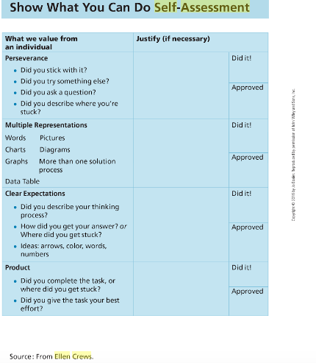

Wrap up: Discuss the power of exponents. How is 2⁵ different that 2*5? Why does that matter?

Follow up learning: The following lesson will introduce multiplying powers with the same base.

Bibliography:

Boaler, Jo. Mathematical Mindsets. Jossey-Bass, 2016.

Kaplinsky, Robert. Problem Solving Framework v8.1, http://robertkaplinsky.com/wp-content/uploads/2017/02/Problem-Solving-Framework-v8.1.pdf.

