Title: Disneyland Circle Subject: Geometry
Grade: 9-12 Time: 1-2 Class Periods
Objective: Students will determine the length of an arc in a circle.

Anticipatory Set: Short Entry Ticket on central angles and arc measure.

Procedure:
- Give each group the Disneyland problem (below) and assign group members roles.
- Students may use any methods to determine the length, but must use mathematical reasoning to convince.
- For groups that finish early, ask them to figure out how to explain to a younger sibling the similarities and differences between measure and length.

Guided Practice: Place of Charles de Gaulle, Paris
Find the distance around the circle from Av. Des Champs-Elysees to Avenue Foch. The diameter of the circle is approximately 108 meters.
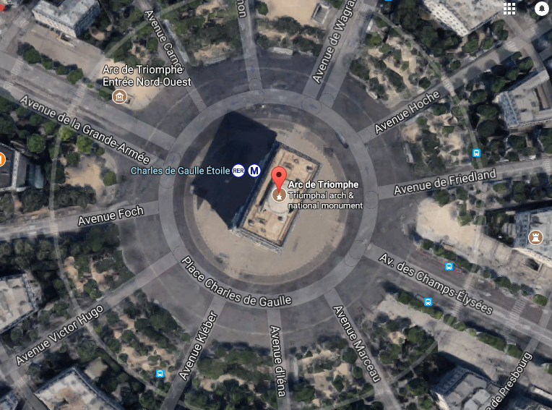
Independent Practice:
Have students try either Practice Arc Length or Challenge Problems Arc Length 1 or Challenge Problems Arc Length 2 on Khan Academy.

Formative Assessment:
Students complete a self-reflection:
- What was the big idea we learned today?
- What good ideas did I have today?
- This lesson made me think about?

Student Self-Assessment:
 | I can do this independently and explain my solution to others. | I can do this independently, but need help explaining my solution to others. | I need more time to understand the concept and how to explain it to others.
Find circumference, given diameter or radius.

Find the measure of an arc, given a central angle.

Find arc length using circumference and arc measure.

Work backwards from arc length to find measure, circumference or radius.

Create a math problem for another student.

Group Task: Disneyland
Sam is at the Horseless Carriage in Disneyland. Sam’s cousin wants to walk to the Turkey Leg Cart and Sam’s friend to the Horse Drawn Streetcars. Sam’s feet are super tired from walking all day, so says that they should all only walk to the closest one. The diameter of the circle is approximately 160 feet.
Compare the distances to the two locations and determine which is closer. Use mathematical justification and reasoning.
Determine the distance around the circle to travel to your chosen location.
Relate the distance to the circumference of the circle.

