Tara Termes Instructor: Brenda McKinney ED 548K Mindset: The New Psychology of Success
Date: 05/21/2017 500 Level Assignment 12
Group Leader: Tara Termes
Authored by: Tara Termes

Mindset Lesson Plan
Time: 2- 45 minute class periods
Objectives:
Students will learn the difference between a fixed and a growth mindset.
Students will learn strategies for shifting from one mindset to the other.

1. Students will complete a survey monkey survey as their daily opener.
https://www.surveymonkey.com/r/SHT6VS3
The question is: Give an example of something in your life you would never quit or give up
on, even if it was hard for you.

I think students will have a difficult time answering this question because a lot of them want to know “what I am looking for” and they are afraid of giving a “wrong answer” even though that is impossible. I am curious to see what sort of answers I receive.

2. Students will take the following self assessment, score themselves and write down their result.
Adapted from: http://www.classroom20.com/forum/topics/motivating-students-with and
from“The Curse of the ‘Smart’ Student” at extremebiology.net.

Place a check in the column that identifies the extent to which you agree or disagree with the statements.
Statements | Agree | Disagree
1. My intelligence is something very basic about me that I can’t really change.
2. When I don’t understand something I like to slow down and try to figure it out.
3. I am intimidated by academic challenges.
4. I have been told by others that I am smart.
5. Learning is fun.
6. I often feel unmotivated to learn.
7. When I don’t do well in a subject I think that I must not be very good at that particular subject.
8. When I perform poorly academically I do not get discouraged.
9. When I don’t understand something, I get very frustrated and want to give up.
10. I shouldn’t have to work as hard in subjects that I am naturally good at.

Scoring is as follows:
• Give yourself 4 points each time you answered AGREE to these questions:
1, 3, 4, 6, 7, 9, 10
• Subtract two points for each time you answered AGREE to these questions:
2, 5, 8
• If you scored:
less than 5, you have a growth mindset.
between 5-10, you have a growth mindset with some fixed ideas.
between 11-15, you have a mostly fixed mindset.
above 15, you have a solidly fixed mindset.

3. Students will view a powerpoint regarding fixed and growth mindsets. I downloaded it from
Slide Share and made a few minor changes to it. I will present slides 1-11 to the students and
answer questions about the brain as we move through it. This fits in very well with our
curriculum as we have been learning about body systems and just discussed the organs in the
central nervous system in class Friday. Slides 1-11 are shown below.
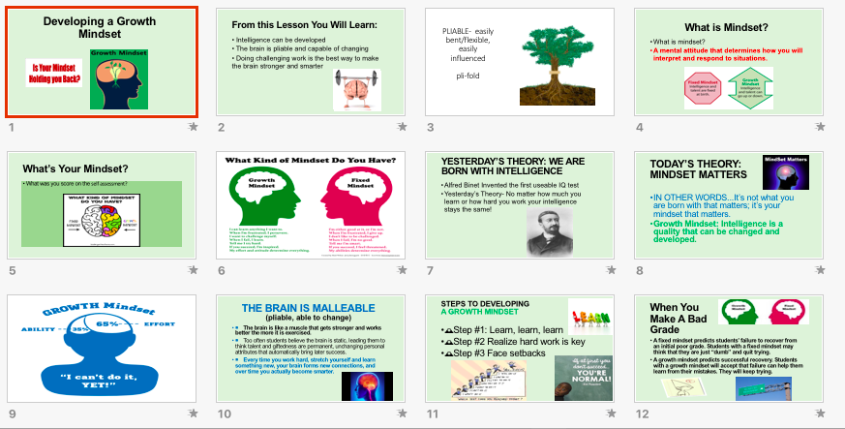

4. Brainstorm- How can one shift from the fixed mindset to the growth mindset? I will ask
students to come up with a list of ideas about how to develop a growth mindset. Some groups
will share out. This will give me a feel for if they are getting the idea of what types of
characteristics make up the growth mindset. I will then show them slides 12-16.
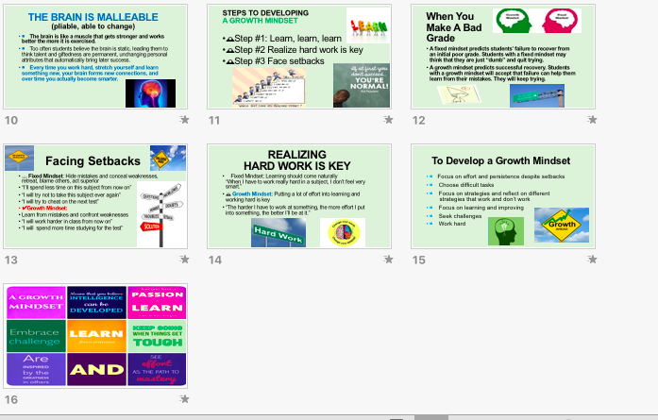
5. Students will read the article in groups. I will ask them to circle unfamiliar words. I expect that some students will circle neuroplasticity, neuroscience, neural networks, and electrochemical pathways, and malleable. I will ask to draw a box around what they view as the most important points from the article. I will prepare some vocabulary slides to show students if there are questions regarding the vocabulary.

https://www.edutopia.org/neuroscience-brain-based-learning-neuroplasticity

I want to share the following with students:
- Intelligence is not fixed nor planted firmly in our brains from birth. It can be developed throughout our lives.
- When people repeatedly practice an activity or access a memory, their neural networks -- groups of neurons that fire together shape themselves according to that activity or memory.
- If you perform a task or recall some information that causes different neurons to fire at the same time, it strengthens the connections between those cells
- A study in the journal Child Development in 2007 that found that both morale and grade points took a leap when students understood the idea that intelligence is malleable. Not only did those students who already believed this do better in school, but when researchers actively taught the idea to a group of students, they performed significantly better than their peers in a control group
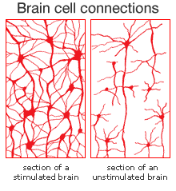

6. Students will watch the video: https://www.youtube.com/watch?v=2zrtHt3bBmQ
While this video is very simplistic, it represents the minimum amount of information I want
ALL students to learn. Your brain is like a muscle- the more you exercise it, the better it will
function. I want students to feel like there is hope for them as students.

7. Exit Ticket: Students will complete an exit ticket on Padlet. They will answer the following
question: What did you learn today about yourself and about your brain?

