Name: Anatoliy V. Andrukhovich

Date: June 25, 2017

Course: Mindset: The New Psychology of Success

Instructor: Brenda McKinney

Assignment: Mindset #12A

**Elementary Guidance Lesson Plan**

**Teacher:** Anatoliy Andrukhovich

**Lesson:** #1

**Unit:** Self-Esteem & Academic Success

**Title:** Growth Mindset vs. Fixed Mindset

**Grade Level:** First

**Students:** 27 students, 15 girls and 12 boys

**Languages in the classroom**: English, Spanish, Vietnamese, Russian, Ukrainian, Caren, Samoan, and Somali dialects

**Time:** 35-40 Minutes

**Learning Target:**

By the end of the lesson, the students will be able to identify the characteristics of the growth and fixed mindsets as well as understand how to develop a growth mindset

**Students Friendly Learning Target**: I can understand the meaning of a fixed and a growth mindset.

**Vocabulary:** fixed mindset, growth mindset, effort, brain, neurons, communication

**Materials:**

* Pictorial Input Chart traced and prepared with the pencil only
* Pencils and markers
* Post-it notes for students

A copy of a chart used in this lesson attached below

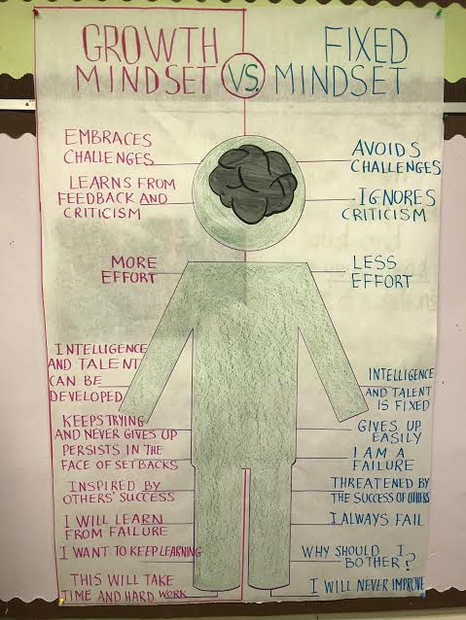

**Learning Activities:**

1. Teacher will write the word **mindset**on the boardand will allow students to guess its meaning. The students may say: “when your mind is set on something” and “how your mind thinks about things.”
2. Teacher will trace the person and the brain on the pictorial input chart and write the statements one at a time for fixed then growth mindsets.
3. Teacher will Talk about **closed vs. open mindset** on a separate piece of paper. Teacher will explain that another word for fixed is closed, and another word for growth is open.
4. Teacher will then pair the students up and provide them an opportunity to discuss the difference.
5. Students comments on what their partner shared about the mindsets.
6. Teacher will explain that when someone is of a **fixed or a closed mindset** they give up easily, they don’t try things that might be hard, and they don’t believe that they can learn. Give a few examples of what someone with a **closed mindset** would say: “This is too hard,” “I can’t do this,” “I don’t like school”, “I’m not going to try,” “I am not smart enough.” Ask them how well someone with that kind of mindset would learn; not very well at all! Teacher will refer to the pictorial input chart statements.
7. Teacher will explain that when someone has **an open or a growth mindset**, they don’t give up, they work hard and make an extra effort, besides, they believe they can learn and that their brain can grow. Examples of what someone with an **open or growth mindset** would say: “This is hard, but I’m going to keep trying,” “I can do this.” Students with this kind of mindset would learn more, and much quicker and much better. Teacher will refer to the statements on the pictorial input chart.
8. Teacher will discuss the power of **yet**!
9. Each student will be given the post-it notes with statements on both mindsets.
10. Teacher read a statement one at a time. The student with the matching sentence on their post-it note will stick it next to the sentence on pictorial input chart.
11. Students will practice the sign for each mindset:

***(closed (fixed) on the left, open (growth) on the right with fingers wiggling)***



1. Students will then watch a video on not giving up at https://www.youtube.com/watch?v=xd63g3d8qOs&list=PLnah-hqu5MaQY5t2GjBAwt9E7iJFYPsOA
2. In closure, teacher will ask students what an open (growth) mindset is and elicit responses. Teacher then will ask what a closed mindset is and elicit responses.
3. As a post-assessment, each student will be given a worksheet on both mindsets and will be given an opportunity to write down they responses and draw.

**Comments on the lesson delivery and anticipatory set:**

It turned out to be a great lesson. I must also mention that at the beginning of the lesson I have chosen the scouts: two students who were ‘watching’ other students, and at the end of the lesson chose the students who were respectful, responsible, listened to the teacher, and overall were focused on the lesson. This was a great incentive for the students, and provided me with an extra behavior management tool. The students overall were active and attentive. When I started to lose their attention a little, I gave them the post-it notes. That kept them going for a little longer. Another ‘hook’ was the video. Of course, when the students completely exhausted their attention, I showed them a quick and engaging video on the topic. I ended the lesson with sending the students to work with their respetful teams on the post-assessment assignment. The lesson went well and was engaging.