Mini-Lesson 2: Main Character Questionnaire/Consideration in creating a character

Note: These mini-lessons are intended to be used in a writer’s workshop. I included either my own writing or current published literature as mentor texts for each of these three lessons. References to Atwell are from her 2015 book In The Middle: A Lifetime of Learning About Writing, Reading, and Adolescents. A text that focuses on creating and facilitating reading and writing workshops.

The intent of this mini-lesson is to introduce the concept of developing a character for a micro-fiction.

- Gather students
- Introduce concept of developing a character for a micro-fiction in order to guide writing.
- Showcase my use of the questionnaire/Atwell’s consideration table to guide my creation of “Parking Lot” (a teacher created piece of micro-fiction.
- Have students compare and discuss the questionnaire and the short fiction.
- Have students go out and fill out a questionnaire for either a new piece of writing or a previous piece of short fiction.

Main Character Questionnaire
- What’s your name?
- How old are you?
- What’s the problem you’re facing
- What’s you family background?
- Where do you live?
- What do you like to do?
- What’s different about you?
- What do you care about?
- What do you fear?
- What are your dreams?
- Who are the important people in your life?
- What are the important things in your life?
- How will you change through confronting your problem?

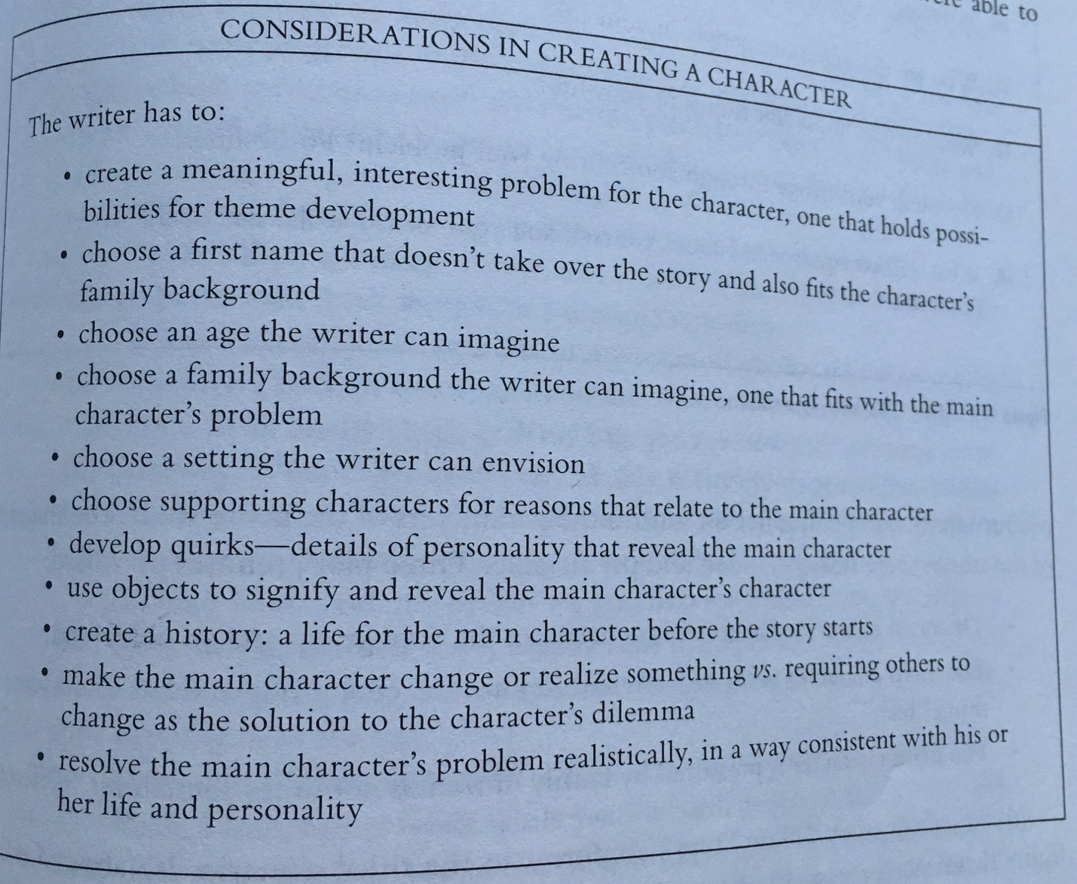

Main Character Questionnaire for “Parking Lot”
- What’s your name? Emily
- How old are you? 23
- What’s the problem you’re facing? I am at the mall trying to take advantage of a sale. I’m not the most flush, so this will be a good opportunity for me to get some things I need. Also, my car is not very good, and it is a hot day with no parking.
- What’s you family background? We get by.
- Where do you live? Portland, yet today it feels like the sun.
- What do you like to do? I like to listen to music, which I can’t do in my car. I also like to shop, but I can only do that when things are on sale or I save for quite a while.
- What’s different about you? I have two jobs.
- What do you care about? Getting by
- What do you fear? Not being able to get by
- What are your dreams? Making it through life better than I am now.
- Who are the important people in your life? My family, my friends.
- What are the important things in your life? Being able to provide for myself.
- How will you change through confronting your problem? I will be more resilient. I make it through another day.

“Parking Lot”
by Nicholas Erickson

I adjust my body slowly, hoping I can extricate myself from the molecular bond that has formed between myself and the leather of this seat. I exhale and reach toward the nob for the AC.
Maybe this time it will turn on…
I am greeted by warm air that is both stagnant and rich with the smell of something that is the opposite of what one would call appealing.
It doesn’t matter, I’ll find a spot and be out of the car soon enough.
If only the AC was the only thing in this car that decided it wanted a new calling.
I resign myself to focus on the parking lot as I make another circuit. It seems that I am not the only one who heard about the DEALS DEALS DEALS (trademark pending) and decided that I could finally afford to make some much needed purchases.
The assault ripples as I slowly drive in search of the telltale signs of movement. Be the rich red of reverse, or slowly stalking people laden with bags.
I am not the only one circling this place, us parking lot vultures.
Movement to the left.
A young woman is precariously balancing two bags while holding the hand of an ice faced child. I creep slowly behind, matching pace.
It is a one way, if she finds her car soon, the bounty will be all mine.
I am the epitome of patience. I am the humblest stillness this parking lot has ever seen.
She turns left.
She stops at a lipstick red Mazda.
I have won. I am first in line.
My blinker flashes triumphantly, claiming the spot.
I am the lion, about to bring down the gazelle.
The car backs up, pivoting, creating the space my car shall find a home.
As it pulls away, it reveals another.
My eyes meet the challenger. I have seen this car circling the labyrinth that shall be our tomb.
It glints in the sun, fresh paint, fresh rims. Everything my car is not.
I shake my head. I have claimed this prize.
My car jerks as I begin to turn, asserting my hold.
The other car smiles as it darts, swooping in for what is rightfully mine.
My heart sinks. My eyes fill. Where is Virgil standing tall, ready to guide me. He must be around the next bend.
A loud CRUNCH emanates from my lost prey. I look to see the driver jump out. Face red, his fists beat upon the car that is mine’s foil.
Advice long since given bubbles up, One should pull in to a spot slowly. To rush is to open oneself up to the unknown. Ignorance is not an excuse accepted by insurance agencies.
I round the next bend, eyes slowly searching for a spot to rest my weary head.

Main Character Questionnaire Student Example (by Kerstin)

- What’s your name? Kerstin the magnificent
- How old are you? 10
- What’s the problem you’re facing? Aliens are trying to take the school.
- What’s you family background? We’re from California
- Where do you live? I live in Portland
- What do you like to do? I like video games, playing soccer
- What’s different about you? I am the only one who is not affected by alien technology
- What do you care about? my friends
- What do you fear? sharks
- What are your dreams? becoming an astronaut
- Who are the important people in your life? my mom, my best friend Tae
- What are the important things in your life? saving the day
- How will you change through confronting your problem? I will be a hero

