Area & Perimeter Playground (Grade 3)
Standards:
- 3.MD.C.5 Recognize area as an attribute of plane figures and understand concepts of area measurement.
- 3.MD.C.6 Measure areas by counting unit squares (square cm, square m, square in, square ft, and improvised units).
- 3.MD.D.8 Solve real world and mathematical problems involving perimeters of polygons, including finding the perimeter given the side lengths, finding an unknown side length, and exhibiting rectangles with the same perimeter and different areas or with the same area and different perimeters.
- 3.MD.C.7 Relate area to the operations of multiplication and addition.

Objective: When given the area, students will be able to find the perimeter of a square or rectangle. They will be able to draw the shapes and express them equations.

Materials:

- handout with playground information (see following page)
- grid paper
- scissors
- pencil
- color pencils/crayons/markers
- large piece of paper
- glue stick
- extra scratch paper
- student pairs or triplets

Guided Introduction:
- Introduce task and group norms: Each student needs to help and participate.
- Group students into pairs or triplets.
- Pass out materials.

Independent Practice:
- Students will work on the task in their pair or triplet.
- When task is complete, students will have a poster of playground. Within each grid shape will be the dimensions of the shape expressed in a multiplication equation.

Guided Discussion: Students will share their thinking and their results. We will record it on a chart to look for and discuss patterns. Discuss the pros and “areas to improve” of their group work and project.

Closure: Assign each group to another group’s poster. Students fill out 2 Stars & a Wish.
Guided Discussion: Students will share their thinking and their results. We will record it on a chart to look for and discuss patterns.
Assessment: Students will complete a similar task.

Wanted: Playground Designer

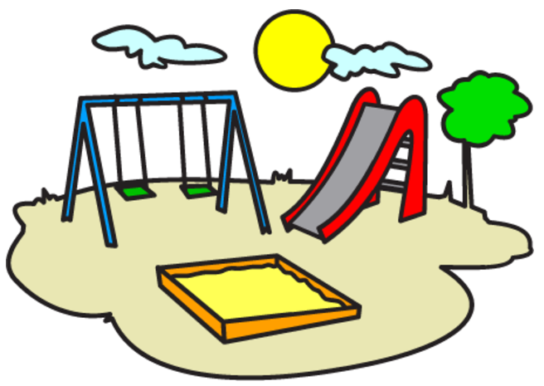
Your task is to design a playground. In order to help the children stay healthy, happy, and safe, the architects and builders need to have the correct dimensions for each piece of equipment in order to build them. Your job is to help the architects and builders determine what the dimensions of each space will be. The requirements are as follows:

The space for each piece of equipment is required to be a square or rectangle.

1. The monkey bars need an area that is 18 square meters.
2. Each slide needs each need 12 square meters of space. There are 2 slides
3. The swing set requires a large area of 60 square meters.
4. Half of a basketball court requires 225 square meters. The kids want a full size court.
5. A climbing wall requires 24 square meters.
6. The playground needs a fence that surrounds it. Determine the perimeter of the whole playground so that the builders know how much fence to purchase.

Extension A: Determine alternate dimensions for each piece of equipment that will still fulfill the area requirement.

Extension B: Choose a piece of equipment and determine the dimensions of the space if it could be any polygon (not a rectangle or square).

Extension C: Think of other pieces of equipment that could be on a playground. Determine the space required for each one.

