U.S. History

A TWO-DAY LESSON ON THE PEARL HARBOR ATTACK

Students Will Be Able To:
- Understand why the United States was reluctant to enter World War II
- Understand why the U.S. entered World War II
- Understand the impact of the Pearl Harbor attack on U.S. Pacific fleet
- Understand what the Pearl Harbor attack felt like on the ground

1. LECTURE NOTES

U.S. isolationism between wars
- Reasons:
  - Xenophobia
  - Pacifism
  - Backlash from immigrant groups oppressed during WWI by “patriotism”
  - 250,000 soldiers dead in WWI for reasons unclear to American public
  - idea that “merchants of death,” military contractors, had hijacked U.S into going to war for their own profit
- Neutrality Acts
- Johnson Act of 1934 – forbade extension of credit to countries that had not paid U.S. back for loans during WWI
- Neutrality Act of 1935 – prohibited the export of “arms, ammunition, and implements of war” from U.S. to foreign nations at war
  - required arms manufacturers in U.S. to apply for an export license
  - Americans traveling in war zones did so at their own risk
  - Roosevelt opposed this but relented in the face of strong Congressional and public opinion
- Neutrality Act 1937 – U.S. citizens forbidden from traveling on belligerent ships; U.S. merchant ships prevented from transporting arms to belligerents even if they were produced outside the United States
  - president had authority to bar all belligerent ships from U.S. waters
- War begins, Sept. 1939
  - FDR states that U.S. will remain neutral in law, but can’t ask Americans to remain neutral “in thought”
  - FDR made significant efforts to help nations engaged in the struggle against Nazi Germany
    - Wanted to extend helping hand to those that were short on supplies
  - FDR wanted to provide assistance to the British, but public fears about being drawn into the conflict blocked plans
  - Neutrality Act of 1939 – lifted arms embargo and put all trade with belligerent nations under the terms “cash-and-carry”
    - could buy non-military stuff from U.S. but had to pay for it immediately
- Lend Lease Act, proposed Dec. 1940
  - In 1940, British (Churchill) state that they cannot pay for supplies anymore
  - FDR proposed a new initiative that would be known as Lend-Lease
  - The U.S. would provide Great Britain with supplies it needed but would not insist on being paid right away
    - The U.S. would “lend” the British war materiel and would be paid later
    - When they did decide to be paid, they would not insist on being paid in dollars
      - Because of interallied war debts of the 1920’s and 1930’s demonstrated it was unreasonable to expect bankrupt European countries to pay back debts
      - With Britain, supplies were paid for with promise of joint action to create a liberal economic order in the postwar world
    - For FDR, Lend-Lease was a way of defeating the Nazis until an American public was on board with going to war

- Road to Pearl Harbor (743)
  - Japanese and American expansion
    - Japan took advantage of WWII crisis to expand itself in the Pacific
    - Tripartite Pact – loose defensive alliance with Germany and Italy that seemed to extend the Axis into Asia
    - Roosevelt had already shown hostility toward Japan
      - by harshly denouncing their assault on China in 1937 and ending a longstanding American commercial treaty with Tokyo government
      - U.S. also put embargo on oil trade with Japan
    - When Tokyo refused to respond to Roosevelt’s stern warnings, president froze Japanese assets in the U.S. and established complete trade embargo (limiting Japan’s ability to purchase essential supplies)
        - U.S. public opinion supported this
    - Choice for Japan: repair relations with the U.S. to restore flow of supplies, or find those supplies elsewhere
      - Deprived Japan of 80% of its oil imports
      - U.S. knew it would act to try and remedy this situation → oil-rich Dutch East Indies would be the target
      - At first, compromise? Request for meeting with Roosevelt was denied, negotiations collapsed
  - Tokyo’s Decision for War
    - For several weeks, Tojo kept up appearances of wanting to continue negotiations
    - Tojo sent negotiators into U.S. to discuss China question, even though Tojo already decided he would not negotiate on China
      - Washington made it clear it would not accept anything less than reversal of that policy
    - U.S. intelligence had already decoded Japanese messages that stated an attack was imminent in the next few days (Nov. 27)
      - Did not know where the attack would take place
      - Most officials believed Japanese would move first against British or Dutch territories, not on U.S.
      - Combination of confusion and miscalculation led to overlooking attack on Hawaii, which to many seemed impossible (many officials tracking large Japanese convoy in South China Sea)
  - The Attack
    - At 7:55 AM on Dec. 7, 1941, wave of Japanese bombers took off from aircraft carrier a hundred miles away
    - Military commanders in Hawaii had taken no precautions against an attack
      - Ships in harbor stacked up, airplanes in rows
      - Within two hours, U.S. lost 8 battleships, 3 cruisers, 4 other vessels, 2,000 soldiers, 1,000 injured
    - American forces greatly diminished in the Pacific, BUT American people were unified in their desire for war after this
    - Dec. 11, everybody at war with each other
  - American response
    - Pearl Harbor changed American ideas about WWII
    - Americans united in cause of going to war
      - After Roosevelt’s speech to Congress, House of Reps voted 388 to 1 to go to war, Senate voted unanimously
      - America declared war on Japan, Germany and Italy declared war on America, and America declared war on Germany and Italy
    - Dec. 8, 1941 – U.S. declares war on Japan
    - Dec. 11, 1941 – U.S. declares war on Germany

2. SOURCE PACKET (BELOW)

3. PEARL HARBOR BATTLE SCENE CLIP WITH QUESTIONS
- How did the element of surprise contribute to Japan’s successful invasion?
- What difficulties did U.S. soldiers have on the ground during the attack?
- Why might the Japanese have attacked Pearl Harbor?
- Why might it not have been a complete success for the Japanese?

The attack on Pearl Harbor thrust the United States into World War II. The attack had significant and far-reaching political effects on the United States, changing the minds of many who had been philosophically opposed to war or who had taken a passive stance towards the war in Europe. The increasing diplomatic confrontations and economic sanctions against Japan by the United States and others, compounded by Japan's undeclared war in China and the weakening of European control in Asian colonies, precipitated the war in the Pacific. The Japanese felt that the time was opportune to conquer British, American, French, Chinese, and Dutch territories in Southeast Asia. This belief pushed militaristic factions in Japan to provoke war with the United States. Fearing that the United States Pacific Fleet would pose a formidable obstacle to Japanese conquest of Southeast Asia, Admiral Isoruko Yamamoto, Commander-in-Chief of the Japanese Combined Fleet, visualized a bold attack on the Pacific Fleet while it lay at anchor at Pearl Harbor. Such a surprise strategical attack, bold and daring in its execution, would, he believed, secure the Pacific.
Map 1
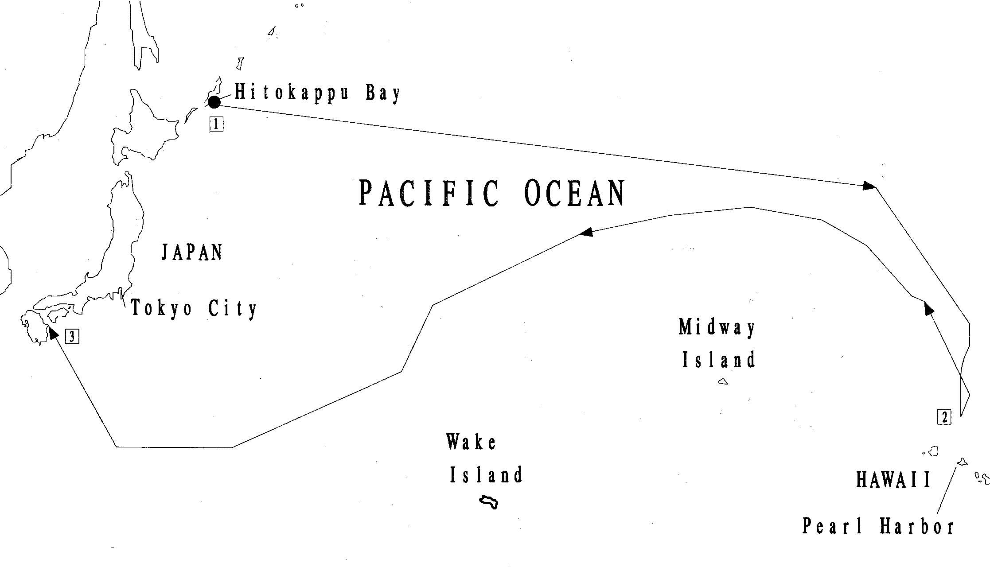
Tokyo Time | Hawaii Time | Washington, DC Time
1 | Nov. 26--0600 | Nov. 25--1030 | Nov. 25--1600
2* | Dec. 8--0130 | Dec. 7--0600 | Dec. 7--1130
3 | Dec. 23 | Dec. 22 | Dec. 22
*First wave aircraft began launching.

The Japanese fleet that set out for the Hawaiian Islands consisted of 33 warships and auxiliary craft, including six aircraft carriers.
1. When did the Japanese set out on their attack?
2. When did the Japanese return to Japan?
3. Why do you think so much time elapsed in between? (Additional information is found in Reading 1.)
Map 2
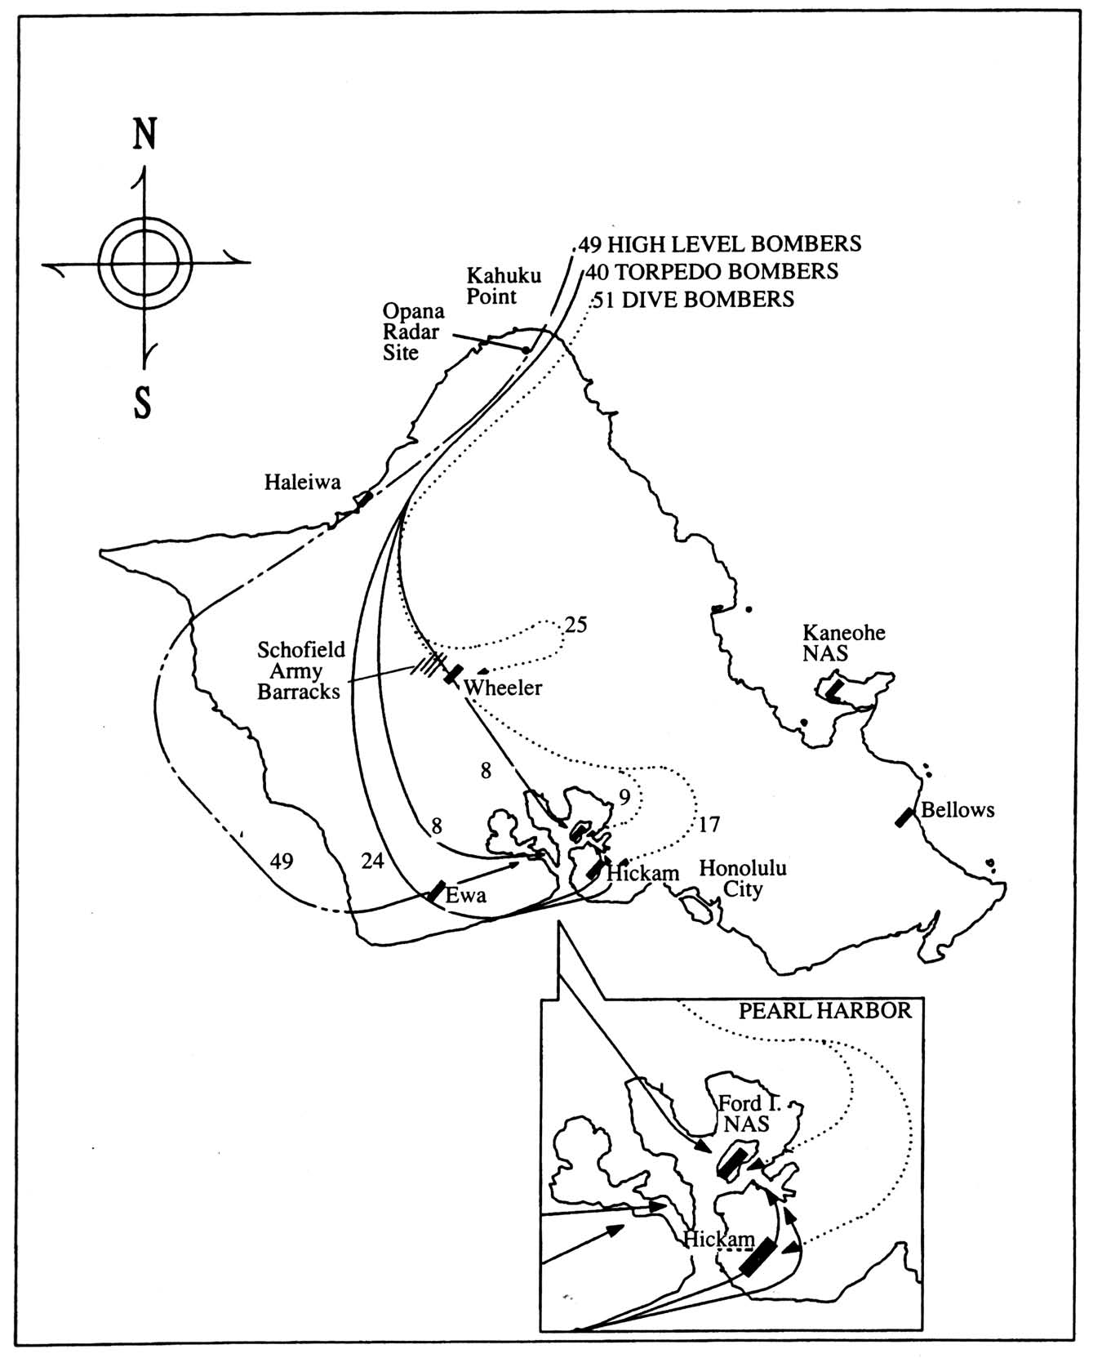
Not only Pearl Harbor, but every military installation on the island of Oahu was attacked on December 7, 1941.
1. What types of aircraft were used in the attack?
2. Trace the route of each type of aircraft.

Map 3
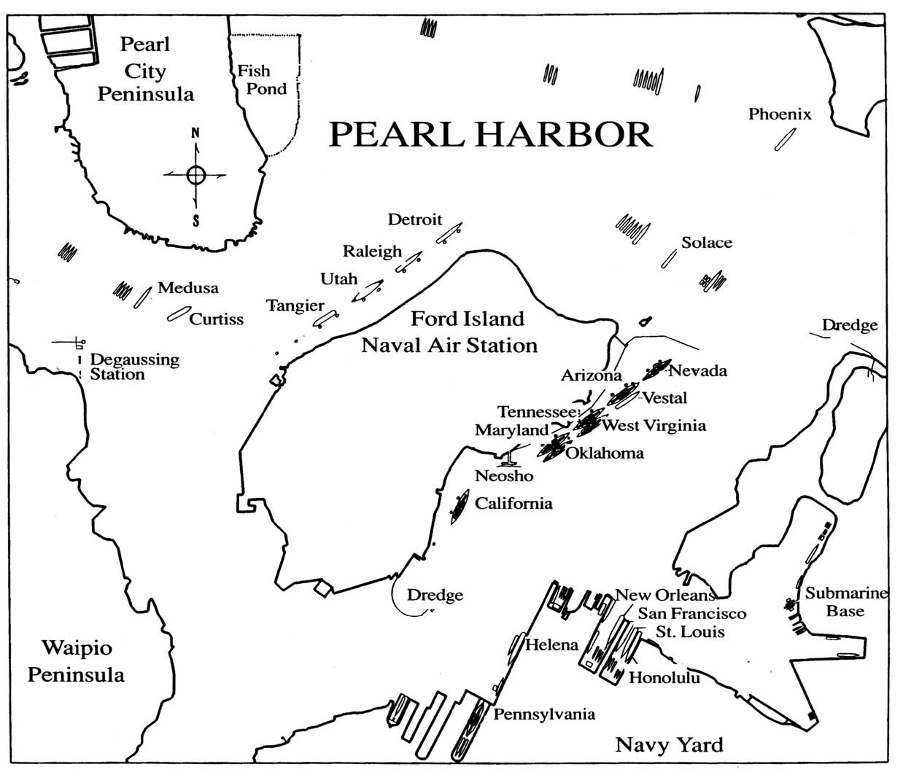
At the time of the attack, the 130 vessels of the U.S. Pacific Fleet lay at Pearl Harbor.
1. Note the location of Ford Island Naval Air Station on Map 3 and then locate it on Map 2.
2. Locate the USS Arizona.
3. Does this map help you understand why the Japanese believed that a victory here would secure the Pacific? Why or why not?

Reading 1: The Attack on Pearl Harbor
(Refer to Maps 1, 2, and 3 as you read the description of the attack.)
The attack on Pearl Harbor was the culmination of a decade of deteriorating relations between Japan and the United States over the status of China and the security of Southeast Asia. This breakdown began in 1931 when Japanese army extremists, in defiance of government policy, invaded and overran the northern-most Chinese province of Manchuria. Japan ignored American protests, and in the summer of 1937 launched a full-scale attack on the rest of China. Although alarmed by this action, neither the United States nor any other nation with interests in the Far East was willing to use military force to halt Japanese expansion.
Over the next three years, war broke out in Europe and Japan joined Nazi Germany and Fascist Italy in the Axis Alliance. The United States applied both diplomatic and economic pressures to try to resolve the Sino-Japanese conflict. The Japanese government viewed these measures, especially an embargo on oil, as threats to their national security. By the summer of 1941, both countries had taken positions from which they could not retreat without a serious loss of national prestige. Although both governments continued to negotiate their differences, Japan had already decided on war. The attack on Pearl Harbor was part of a grand strategy of conquest in the western Pacific. The objective was to immobilize the Pacific Fleet so that the United States could not interfere with invasion plans. The principal architect of the attack was Admiral Isoroku Yamamoto, Commander-in-Chief of the Japanese Combined Fleet. Though personally opposed to war with America, Yamamoto knew that Japan's only hope of success in such a war was to achieve quick and decisive victory. If there were a prolonged conflict, America's superior economic and industrial power would likely tip the scales in her favor.
On November 26, the Japanese attack fleet of 33 warships and auxiliary craft, including 6 aircraft carriers, sailed from northern Japan for the Hawaiian Islands. It followed a route that took it far to the north of the normal shipping lanes. By early morning, December 7, 1941, the ships had reached their launch position, 230 miles north of Oahu. At 6 a.m., the first wave of fighters, bombers, and torpedo planes took off. The night before, some 10 miles outside the entrance to Pearl Harbor, five midget submarines carrying two crewmen and two torpedoes each were launched from larger "mother" subs. Their mission: enter Pearl Harbor before the air strike, remain submerged until the attack got underway, then cause as much damage as possible.
Meanwhile at Pearl Harbor, the 130 vessels of the U.S. Pacific Fleet lay calm and serene. Seven of the fleet's nine battleships were tied up along "Battleship Row" on the southeast shore of Ford Island. Naval aircraft were lined up at Ford Island and Kaneohe Bay Naval Air Stations, and Marine aircraft at Ewa Marine Corps Air Station. At Hickam, Wheeler, and Bellows airfields, aircraft of the U.S. Army Air Corps were parked in groups as defense against possible saboteurs.
At 6:40 a.m., the crew of the destroyer USS Ward spotted the conning tower of one of the midget subs headed for the entrance to Pearl Harbor. The Ward sank the sub with depth charges and gunfire, then radioed the information to headquarters. Before 7 a.m. the radar station at Opana Point picked up a signal indicating a large flight of planes approaching from the north. These were thought to be either aircraft flying in from the carrier Enterprise or an anticipated flight of B-17s from the mainland, so no action was taken.
The first wave of Japanese aircraft arrived over their target areas shortly before 7:55 a.m. Their leader, Commander Mitsuo Fuchida, sent the coded messages "To, To, To" and "Tora, Tora, Tora," telling the fleet that the attack had begun and that surprise had been achieved.
At approximately 8:10, the USS Arizona exploded, hit by a 1,760-pound armor-piercing shell that slammed through her deck and ignited her forward ammunition magazine. In less than nine minutes, she sank with 1,177 of her crew. The USS Oklahoma, hit by several torpedoes, rolled over, trapping more than 400 men inside. The USS California and USS West Virginia sank at their moorings, while the USS Utah, converted to a training ship, capsized with more than 50 of her crew. The USS Maryland, USS Pennsylvania, and USS Tennessee all suffered significant damage. The USS Nevada attempted to run out to sea but took several hits and had to be run aground to avoid sinking and blocking the harbor entrance.
While the attack on Pearl Harbor intensified, other military installations on Oahu were hit. Hickam, Wheeler, and Bellows airfields, Ewa Marine Corps Air Station, Kaneohe Bay Naval Air Station, and Schofield Barracks suffered varying degrees of damage, with hundreds of planes destroyed on the ground and hundreds of men killed or wounded.
After about five minutes, American anti-aircraft fire began to register hits, although many of the shells that had been improperly fused fell on Honolulu, where residents assumed them to be Japanese bombs. After a lull, at 8:40 a.m. the second wave of attacking planes focused on continuing the destruction inside the harbor, destroying the USS Shaw, Sotoyomo, a dry dock, and heavily damaging the Nevada, forcing her aground. The Japanese also attacked Hickam and Kaneohe airfields, causing heavy loss of life and reducing American ability to retaliate.
Army Air Corps pilots managed to take off in a few fighters and may have shot down 12 enemy planes. At 10 a.m. the second wave of attacking planes withdrew to the north, and the assault was over. The Japanese lost 29 planes and five midget submarines, one of which was captured when it ran aground off Bellows Field.
The attack was a great, but not total, success. Although the U.S. Pacific Fleet was shattered, its aircraft carriers (not in port at the time of the attack) were still afloat and Pearl Harbor was surprisingly intact. The shipyards, fuel storage areas, and submarine base suffered no more than slight damage. More importantly, the American people, previously divided over the issue of U.S. involvement in World War II, rallied together with a total commitment to victory over Japan and her Axis partners.
1. List the factors that led to the surprise strategical attack of Pearl Harbor. How did the Japanese justify such an attack?
2. What did the Japanese regard as the main purpose of the attack?
3. Why were the United States Pacific Fleet and other military installations caught off guard?
4. Why had diplomatic negotiations broken down?
5. Why was there no declaration of war before the attack?
6. How many battleships were in the area known as "Battleship Row"? What happened to each of them? What happened at other military installations?
7. What damage did the U.S. military inflict on the Japanese?
8. Why was the success of the attack on Pearl Harbor considered "great, but not total"?
Reading 1 was adapted from the National Park Service visitor's guide for the USS Arizona Memorial.

Reading 2: The USS Arizona Memorial
The USS Arizona is the final resting place for many of the ship's 1,177 crewmen who lost their lives on December 7, 1941. The 184-foot-long Memorial structure spanning the mid-portion of the sunken battleship consists of three sections: 1) the entry and assembly rooms, 2) a central area designed for ceremonies and general observation, and 3) the shrine room, where the names of those killed on the USS Arizona are engraved on the marble wall.
The primary concern of the U.S. Navy immediately after the attack had been to repair the damaged ships as quickly as possible. Early on, it became clear that the USS Arizona would never sail again. While other ships were restored, she lay under the water, a silent reminder of the "date which will live in infamy." When the navy began to consider raising the ship and recovering the dead, medical examiners advised that many of the men had been cremated by the blast and ensuing fire, and others would be unrecognizable after being submerged for a long time. The navy then decided to maintain the old custom of sailing men: those who die at sea are buried at sea. They would not, however, be forgotten.
The USS Arizona Memorial grew out of the desire to establish some sort of shrine at Pearl Harbor to honor those of the USS Arizona and all others who died in the attack. Suggestions for such a memorial began in 1943, but it was not until 1949, when the Territory of Hawaii established the Pacific War Memorial Commission, that the first concrete steps were taken to bring it about. Initial recognition came in 1950 when Admiral Arthur Radford, Commander in Chief, Pacific (CINCPAC), ordered that a flagstaff be erected over the sunken battleship. On the ninth anniversary of the attack, a commemorative plaque was placed at the base of the flagstaff.
President Dwight D. Eisenhower, who helped achieve Allied victory in Europe during World War II, approved the creation of the national Memorial in 1958. Its construction was completed in 1961 with private donations and public funds appropriated by Congress. The Memorial was dedicated in 1962.
According to its architect, Alfred Preis, the design of the Memorial, "wherein the structure sags in the center but stands strong and vigorous at the ends, expresses initial defeat and ultimate victory....The overall effect is one of serenity. Overtones of sadness have been omitted to permit the individual to contemplate his own personal responses...his innermost feelings."
Contrary to popular belief, the USS Arizona is no longer in commission. As a special tribute to the ship and her lost crew, the United States flag flies from the flagstaff, which is attached to the severed mainmast of the sunken battleship. The USS Arizona Memorial has come to commemorate all military personnel killed in the Pearl Harbor attack.
1. How did it happen that the USS Arizona became the focus of a memorial to honor all who died at Pearl Harbor? What special recognition is given to the USS Arizona at the Memorial site?
2. How was money raised to build the Memorial?
3. Do you think the architect accomplished his goal for the building? Why or why not?
Reading 2 was compiled from the National Park Service visitor's guide for the USS Arizona Memorial; and James P. Delgado, "USS Arizona Wreck" (Honolulu County, Hawaii) National Register of Historic Places Registration Form, Washington, D.C.: U.S. Department of the Interior, National Park Service, 1988.

Chart 1: December 7, 1941 losses
Personnel Killed | United States | Japan
Navy | 1998 | 64
Marine Corps | 109
Army | 233
Civilian | 48
Personnel Wounded
Navy | 710 | Unknown
Marine Corps | 69
Army | 364
Civilian | 35
Ships
Sunk or beached * | 12 | 5
Damaged | 9
Aircraft
Destroyed | 164 | 29
Damaged | 159 | 74
*All U.S. ships, except the USS Arizona, the USS Utah, and the USS Oklahoma, were salvaged and later saw action.
*Figures are subject to change according to new evidence.

Of the total number of men killed at Pearl Harbor, approximately 1,177 were sailors and marines serving on the USS Arizona. Approximately 333 men aboard the USS Arizona survived the attack.
1. Why was the Japanese casualty list so low compared with that of the United States?
2. What percentage of U.S. losses came from the Arizona?
3. What percentage of the total crew on the Arizona survived?
4. Do these figures help you to understand why the remains of the Arizona were chosen as a site for a memorial? Why or why not?
Information for Chart 1 comes from the USS Arizona Memorial, National Park Service.

Chart 2: Brothers Aboard the USS Arizona,
December 7, 1941
Survivors in Bold Print
Twins marked with an *
1. *Anderson, Delbert J.  John Delmar  2. Allison, Andrew K.  J.T.  3. Ball, William V.  Masten A.  4. Becker, Harvey Herman  Marvin Otto  Wesley Paulson  5. Birdsell, Ryan Delois  Estelle  6. Bromley, George Edward  Jimmie  7. Chandler, Donald Ross  Edwin Ray  8. Chapman, Naaman  Noel B.  9. Christiansen, Edward Lee  Harlan Carl  10. Conrad, Homer Milton, Jr.  Walter Ralph  11. Conlin, Bernard Eugene  James Leo  12. Cooper, Clarence Eugene  Kenneth Erven  13. Czarnecki, Stanley  Anthony Francis  14. Doherty, George Walter  John Albert  John Andrew  15. Flory, Max Edward  Dale Frederick  16. *Heidt, Edward Joseph  Wesley John  17. Ingalls, Richard Fitch  Theodore A.  18. Iverson, Earl Henry  Norman Kenneth |  | 19. Jones, Daniel Pugh  Woodrow Wilson  20. Jones, Edward Ethmer  Homer Lloyd  21. Keniston, Donald Lee  Kenneth Howard  22. Kennington, Charles Cecil  Milton Homer  23. Kramb, James Henry  John David  24. Lakin, Donald Lapier  Joseph Joran  25. Livers, Raymond Edward  Wayne Nichols  26. Miller, George Stanley  Jessie Zimmer  27. Murdock, Charles Luther  Melvin Elijah  Thomas D.  28. Nichols, Alfred Ross  Louis Duffie  29. O'Bryan, George David  Joseph Benjamin  30. Shive, Malcolm Holman  Gordon E.  31. Skiles, Charley Jackson, Jr.  Eugene  32. Starkovich, Charles  Joseph, Jr.  33. Velia, Galen Steve  Keith Lloyd  34. Wells, Raymond Virgil, Jr.  William B.  Father and Son:  Father: Free, Thomas Augustus  Son:William Thomas

When these young men enlisted, there was a general belief that the United States would not become involved in the war in Europe, and little thought that diplomatic and economic problems with Japan would ever result in war. Eventually legislation was passed which prohibited members of the same family from serving on the same ship.
1. Why might brothers hope to be assigned to the same ship? If they had known what was to come, do you think they would still have tried to serve on the same ship?
2. How many families had three sons on board? How many of those sons survived?
3. What else can you learn from this chart?
Information for Chart 2 comes from the USS Arizona Memorial, National Park Service.

Photo 1: USS Arizona sets out from New York for trial maneuvers in 1918.
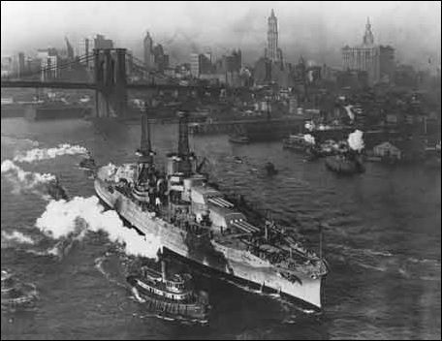
(USS Arizona Memorial)
1. How does the photo help give a sense of the size of the battleship?
2. How long after this trial maneuver did the Arizona sink?

Photo 2: Shattered by a direct hit, the USS Arizona burns and sinks, December 7, 1941.
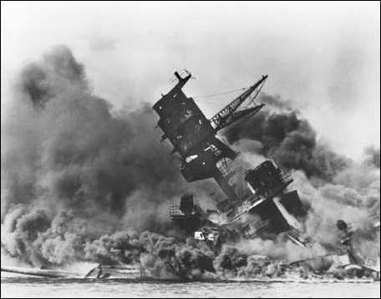
(USS Arizona Memorial)
1. The U.S. Navy did not allow much from the photographic records of the Pearl Harbor attack to be made public in 1941. Why do you think they made that decision?
2. What do you think was the reaction of the American public when they saw this image published in their local newspapers?
3. From examining the photo, can you make out where the USS Arizona was hit and how she sank? Why or why not? If needed, refer to Reading 1 to determine how the USS Arizona sank.

Photo 3a: Aerial view of the USS Arizona Memorial.
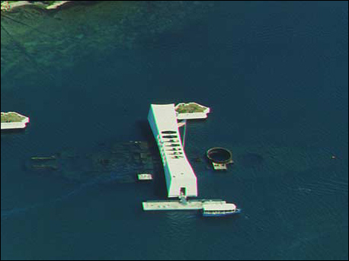
(Hawaiian Service, Inc.)
Photo 3b: The names of the Arizona's dead are inscribed on this white marble wall at the Memorial.
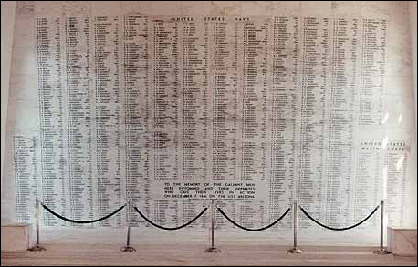
(Beth Boland)
1. Do you think the Memorial is effective in keeping the memory of the war alive? Why or why not?
2. In what ways does the memorial evoke an emotional response? What is your reaction to the Memorial and the USS Arizona?
3. Do you think the Memorial helped to reconcile American and Japanese bitterness over the war? If so, how?

Photo 4: Aerial view of Pearl Harbor today.
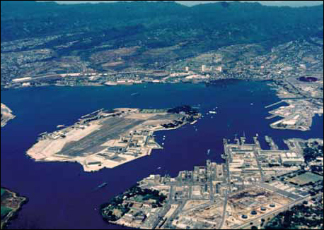
(Hawaiian Service, Inc.)
1. Match the photo to Map 3.
2. Locate the USS Arizona Memorial.
3. Does this photo enhance your understanding of the events of December 7, 1941? If so, how?
3. What kinds of things can you learn from this photo that are not evident in Map 3?

Putting It All Together
Most Americans who were alive in 1941 can remember exactly where they were when they first learned of the Japanese attack on Pearl Harbor. For many of those who served in the armed forces, and families of those who served, the Second World War was the central event of their lives--a source of both pain and pride. The following activities are designed to help students understand some of these feelings. They will also compare how opposite sides in a battle differ in their remembrances of that battle.
Activity 1: Pearl Harbor and the Casualties of War
The attack on Pearl Harbor propelled the nation into a war that lasted for almost four years. On the first day of that war, more than 2,400 Americans died; their average age was 23. Have students consider the impact such enormous losses would have on the American public. Then ask them to imagine they are reporters at the time of the attack on Pearl Harbor. Have each student write a short paper describing how they would have covered the news for their local daily papers. They should include information about the surprise attack, the sinking of the Arizona, and the statistics about the casualties. Have students work in pairs to correct rough drafts. Have three or four students read their completed features aloud and then hold a discussion on the attack and its results.
Activity 2: Comparing Textbook Accounts
Using a typical U.S. history textbook, have students read the account of Pearl Harbor. Then have students read the following paragraph that has been translated from a Japanese history textbook of the late 1960s:
In April 1941, Japan agreed to a Japan-USSR Neutrality Treaty in order to lessen the military threat to the north. This was followed by the occupation of the southern half of Indo-China by Japanese military forces. In consequence, the American attitude towards Japan hardened, and diplomatic relations between the two countries came to a dead end. The Tojo Cabinet conducted its business in extreme secrecy, and in the pre-dawn hours of December 8, 1941 [December 7, Honolulu time], Pearl Harbor in Hawaii was attacked and war was simultaneously declared against the United States and England. The Pacific War was thus begun. (Donald W. Robinson, Editor, As Others See Us, International Views of American History. Boston: Houghton Mifflin, 1969.)
Ask students to cite differences between the two textbook accounts and discuss why they would differ to such a great degree. Have them develop an outline of the information they think should be included in both U.S. and Japanese textbooks. Compare the outlines and discuss differences in treatment.
Activity 3: Survivors of War
Have students meet in small groups to suggest a list of questions they would like to ask a veteran--of any war. List questions on the chalkboard as each group reports and then have the class refine the list and copy the final questions. Either have students use the list during interviews they set up for after school, or for one conducted in the classroom. (Veterans' organizations such as the American Legion, Veterans of Foreign Wars, etc., can usually provide speakers who are willing to go out to classrooms.) When interviews are complete, have students compare responses.
Activity 4: Examining War Memorials
The USS Arizona Memorial records the names of the dead on a white marble wall. The Vietnam Memorial is a black marble wall that rises from the ground. Both commemorate the ultimate sacrifice that is often demanded of our nation's military personnel. Have students look for war memorials in their community. Is there a statue? Lists of the dead? A cannon mounted outside a public building? A special type of tombstone used in the local cemetery for those who served in the military? Are there any World War II memorials? What can students learn about their community's participation in World War II from these memorials (names of those who served, number of people who served, what branch of the military they represented and where they served, etc.)?
Some students may have visited Revolutionary or Civil War battlefields and may have pictures to bring to class. Other students may use library books to find examples of war memorials. Have them compare memorials from different wars by listing the materials they are made of, the size of the monument, the prominence of the memorial in its surroundings, and the dedicatory inscriptions found on the memorial. Then ask them to consider why some wars have been better remembered than others. Does the type of war fought make a difference? Have styles of memorials changed over time? Do all memorials seem fitting to the event? Do they feel the USS Arizona Memorial is appropriate for its purpose?

