School Bus Shapes
Grades K-1
X Total Group Activiy
X Cooperative Activity
X Independent Activity
X Concrete/Mainpulative activity
X Visual/Pictorial activity
X Abstract procedure

Why Do It:
This activity provides students with a visual activity that will help them learn their basic 2D shapes.
You will Need:
Cutout of a yellow school bus, black circles for wheels, different colored circles for heads, blue squares for windows, blue triangle for front window, glue stick, crayons, pencils
How To Do It:
- Hand out the materials each student will need to complete their bus. Make sure they have their names written on the back
- Have students find and name shapes for the wheels. Glue them on.
- Have students find and name the shapes for the windows. Glue them on.
- Have students find and name the shapes for the people on the bus.
- Have students add any other shape features on the bus and name what those are.
- Have students decorate their bus to finish it up, then display for others to see.
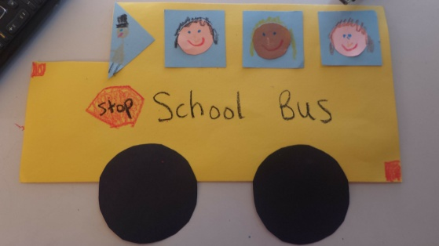
Example:

Extension:
- Instead of providing already cut out shapes, students would have to cut out their own to place on the bus. This causes them to have to understand the different features and how to make them, instead of just pointing the shape out
- Another way to extend would be to only give them circles and triangles and have them figure out how to make the windows using the triangles. There could also be other shapes thrown in there, like trapezoids to make a hexagon.

